“Design and Development of a Food Connect Platform for Donors, NGOs, and Volunteers”
A Project Report Submitted in the partial fulfillment of the requirements for the award of the degree of

BACHELOR OF TECHNOLOGY
In

DEPARTMENT OF COMPUTER SCIENCE ENGINNERING
By

J SAI SHASHANK 2520030433
A ARUN TEJ 2420030472

Under the Esteemed Guidance of

Dr . R . Sateesh Kumar
Assistant Professor
Department of Computer Science and Engineering




K L (Deemed to be) University DEPARTMENT OF COMPUTER SCIENCE ENGINEERING

Declaration

The Project Report entitled “Design and Development of an Integrated Food Donation and NGO Connect Platform” is a record of Bonafide work of J SAI SHASHANK

2520030433 , A ARUN TEJ 2420030472 , submitted in partial fulfillment for the award of B. Tech in Computer Science and Engineering (or) Computer Science and Information Technology to the K L University. The results embodied in this report have not been copied from any other departments/University/Institute.

J SAI SHASHANK – 2520030433

A ARUN TEJ– 2520030472

K L (Deemed to be) University

DEPARTMENT OF COMPUTER SCIENCE ENGINEERING

CERTIFICATE

This is certify that the mini project based report entitled “Design and Development of an Integrated Food Donation and NGO Connect Platform” is a bonafide work done and submitted by
J SAI SHASHANK 2520030433 , A ARUN TEJ 2420030472 , in partial fulfillment of the requirements for the award of the degree of BACHELOR OF TECHNOLOGY in Department of Computer Science Engineering, K L (Deemed to be University), during the academic year 2024-2025.

Signature of the Guide

Signature of the Course Coordinator Signature of the HOD

ACKNOWLEDGEMENT
The success in this project would not have been possible but for the timely help and guidance rendered by many people. Our wish to express my sincere thanks to all those who has assisted us in one way or the other for the completion of my project.

Our greatest appreciation to my Course Coordinator Dr . D . RAMYA KRISHNA , and my guide Dr . D . RAMYA KRISHNA , Department of Computer Science which cannot be expressed in words for his/her tremendous support, encouragement and guidance for this project.

We express our gratitude to Dr. P . VENKATESHWAR RAO (CSE) Head of the Department for Computer Science Engineering for providing us with adequate facilities, ways and means by which we are able to complete this project-based Lab.

We thank all the members of teaching and non-teaching staff members, and also who have assisted me directly or indirectly for successful completion of this project. Finally, I sincerely thank my parents, friends and classmates for their kind help and cooperation during my work.

J SAI SHASHANK – 2520030433

A ARUN TEJ– 2520030472

Abstract

Food waste and hunger are two major social issues that exist simultaneously in society. Restaurants, hotels, events, supermarkets, and individuals often have excess food that is still safe for consumption, while many people and communities struggle to access sufficient food. At the same time, NGOs working to support these communities may face difficulties in identifying available food donations and coordinating their collection and distribution efficiently.
The Food Donation & NGO Connect App is a database-driven platform designed to connect food donors with NGOs that can collect and distribute surplus food to people in need. Donors can register food donations by providing details such as food type, quantity, location, preparation time, and expiry time. Registered NGOs can view available donations, accept suitable requests, and coordinate collection and distribution. The system maintains organized records of donors, NGOs, food donations, requests, pickups, and distribution activities.
The proposed system aims to reduce food wastage, improve communication between donors and NGOs, and make the food donation process more transparent and efficient. A centralized database enables secure storage, retrieval, updating, and management of donation-related information while providing useful records and reports. The project demonstrates the practical application of DBMS concepts such as database design, normalization, SQL queries, relationships, transactions, constraints, and CRUD operations to solve a real-world social problem.

Index

S.  No. | Chapters | Topics | Page.no
 |  | Acknowledgement
 |  | Abstract
1 | Introduction | - Background of the project  - Problem statement  - Scope of the project  - Objective(s)  - Importance of the application  - Target users/audience | 5-15
2 | System Requirements | - Hardware requirements  - Software requirements  - Development tools and frameworks | 16-21
3 | Technology Stack | - Front-end (e.g., React.js, Angular, HTML/CSS)  - Back-end (e.g., Node.js, Django, Spring Boot)  - Database (e.g., MongoDB, MySQL, PostgreSQL)  - Version Control (e.g., Git, GitHub)  - APIs or External services (e.g., Firebase, Stripe) | 22-32
4 | System Architecture | - High-level architecture diagram  - Description of each layer (frontend, backend, database)  - Deployment architecture (e.g., cloud, local, CI/CD  pipelines) | 33-36
5 | Design | 5.2 ER Diagram / Database schema | 37
6 | Implementation | - Module-wise implementation  - Front-end logic (UI rendering, state management)  - API integration  - Authentication & Authorization | 38-47
7 | Features | - List of main features  - How each feature works (user perspective + technical description) | 48-55
8 | Testing | - Postman testing (frontend/backend)  - Integration testing  - Tools used for testing  - Test cases and results | 56-64
9 | Deployment | - Steps to deploy  - Environment configuration  - Hosting of frontend and backend | 65-73
10 | Challenges & Limitations | - Issues faced during development  - Solutions applied  - Current limitations or known bugs | 74-82
11 | Future Enhancements | - Planned features  - Possible integrations or optimizations | 83-88
12 | Conclusion | - Summary of the project  - What was achieved  - Skills learned during development | 89-97
13 | References | - Books, tutorials, APIs, documentation sites used | 98-99

14 | Appendices | - Screenshots of the app  - Sample code snippets  - Installation/setup instructions  - User manual or guide  -Geo Tag photos with guide  -Review forms with guide signatures | 100-105

CHAPTER -1 INTRODUCTION

Background of the Project
Food donation is an important social activity that helps reduce food wastage while supporting people and communities facing food insecurity. The continual advancement of information and communication technologies has transformed how social organizations, donors, volunteers, and beneficiaries can coordinate support activities. Traditionally, food donations were managed through phone calls, personal contacts, local organizations, or direct communication between restaurants, individuals, and NGOs. Today, digital platforms and mobile applications provide opportunities to coordinate donations, volunteers, collection activities, and distribution more efficiently.
Despite this progress, the current food donation ecosystem remains fragmented. Numerous independent organizations, restaurants, charitable groups, and volunteers work toward reducing food wastage and supporting communities in need, yet their activities are often not connected through a common digital platform. A potential donor may not know which NGO requires food, a volunteer may not know where collection assistance is needed, and NGOs may struggle to coordinate available food with their distribution capacity. This disjointed process can result in delays, communication gaps, inefficient coordination, and, in some cases, food being wasted before it reaches people in need.
The idea for this project emerged from observing these challenges and recognizing the opportunity to simplify food donation and distribution through a unified digital system. The proposed website, “Design and Development of a Food Connect Platform for Donors, NGOs, and Volunteers,” aims to provide a single-window solution that connects the major participants involved in the food donation process. By bringing donors, NGOs, and volunteers together on one platform, the system provides a structured and transparent environment for registering donations, identifying requirements, coordinating collection, and monitoring donation activities.
Technological growth in web development, cloud computing, databases, and communication systems has made such coordination platforms increasingly practical. The proposed system can maintain information about available food donations, NGO requirements, pickup locations, volunteers, and donation status. Through a centralized database, users can access updated information and coordinate activities according to their roles and availability. The platform can provide suitable interfaces for donors to submit food details, NGOs to communicate their requirements, and volunteers to assist with collection and transportation. The website is designed using responsive-design principles so that it can function smoothly across laptops, tablets, and smartphones.
Beyond the technical aspect, the project addresses an important social and environmental problem: food wastage. Large quantities of edible food can remain unused after events, restaurants, hostels, households, and other activities, while many communities continue to experience food insecurity. The Food Connect Platform aims to create a communication bridge between available surplus food and organizations capable of distributing it responsibly. Instead of depending entirely on individual phone calls or informal communication, the platform provides a structured mechanism for sharing donation information and coordinating support.
An important feature of the proposed system is the involvement of volunteers. Food donation does not always fail because food is unavailable; in many situations, coordination, transportation, timing, and manpower can become challenges. The platform therefore provides a mechanism through which volunteers can identify suitable collection or delivery activities and offer their assistance. This creates a collaborative ecosystem in which donors provide available food, NGOs coordinate distribution and beneficiary requirements, and volunteers support the movement of food between locations.
Economically, the platform can help reduce unnecessary food wastage and improve the utilization of available resources. Donors can easily communicate information about surplus food, while NGOs can identify relevant donations according to their requirements and operational capacity. Volunteers can participate in activities based on their availability and location. Socially, the system encourages community participation by providing individuals, restaurants, institutions, NGOs, and volunteers with a common digital environment for contributing to food-support activities. Environmentally, reducing avoidable food waste can contribute to more responsible resource utilization and support broader sustainability objectives.
From an academic and engineering perspective, the background of the project lies in combining several core areas of computer science:
- Web Technology: Interactive front-end development using HTML, CSS, and JavaScript, supported by suitable back-end technologies.
- Database Management: Efficient storage and retrieval of donor information, NGO requirements, volunteer details, food donation records, and activity status.
- User and Role Management: Providing separate functionalities for donors, NGOs, volunteers, and administrators according to their responsibilities.
- Software Engineering Principles: Applying modular architecture, scalability, maintainability, security, and systematic development practices.
- User Experience Design: Creating simple and intuitive interfaces that allow users with different levels of technical knowledge to access and use the platform effectively.
This technological foundation ensures that the system is not merely a collection of static web pages but a dynamic, data-driven platform capable of managing donation information and coordination activities. The interface is designed to be simple, informative, and accessible so that donors, NGOs, volunteers, and administrators can perform their respective tasks without unnecessary complexity.
The proposed platform also supports transparency and accountability in the food donation process. Users can view the status of donation activities, while administrators can manage registered users, monitor platform activities, and maintain the reliability of the information provided. Such a centralized approach can reduce communication gaps and provide better visibility into the movement and utilization of donated food.
In a broader context, the project contributes to the development of technology-enabled social welfare and sustainable communities. Digital platforms can play an important role in connecting available resources with organizations and individuals who can utilize them effectively. By encouraging food donation, volunteer participation, and NGO coordination, the proposed system supports responsible consumption and community-oriented initiatives.
To summarize, the background of this project rests on three fundamental observations:
- Existing food donation activities are often disconnected and difficult to coordinate efficiently.
- Rapid technological progress makes centralized digital coordination between donors, NGOs, and volunteers practical and scalable.
- Food donation requires better collaboration, transparency, and community participation to reduce avoidable food wastage and support people in need.
By addressing these points, the project establishes itself as a technology-driven approach toward creating a connected food donation ecosystem. The proposed Food Connect Platform aims to streamline the process from identifying surplus food and registering donations to coordinating volunteers and supporting NGOs, while promoting social responsibility, resource efficiency, collaboration, and sustainability.

Problem Statement

Food donation is an important social activity that helps reduce food wastage while supporting people and communities facing food insecurity. The continual advancement of information and communication technologies has transformed how social organizations, donors, volunteers, and beneficiaries can coordinate support activities. Traditionally, food donations were managed through phone calls, personal contacts, local organizations, or direct communication between restaurants, individuals, and NGOs. Today, digital platforms and mobile applications provide opportunities to coordinate donations, volunteers, collection activities, and distribution more efficiently.
Despite this progress, the current food donation ecosystem remains fragmented. Numerous independent organizations, restaurants, charitable groups, and volunteers work toward reducing food wastage and supporting communities in need, yet their activities are often not connected through a common digital platform. A potential donor may not know which NGO requires food, a volunteer may not know where collection assistance is needed, and NGOs may struggle to coordinate available food with their distribution capacity. This disjointed process can result in delays, communication gaps, inefficient coordination, and, in some cases, food being wasted before it reaches people in need.
The idea for this project emerged from observing these challenges and recognizing the opportunity to simplify food donation and distribution through a unified digital system. The proposed website, “Design and Development of a Food Connect Platform for Donors, NGOs, and Volunteers,” aims to provide a single-window solution that connects the major participants involved in the food donation process. By bringing donors, NGOs, and volunteers together on one platform, the system provides a structured and transparent environment for registering donations, identifying requirements, coordinating collection, and monitoring donation activities.
Technological growth in web development, cloud computing, databases, and communication systems has made such coordination platforms increasingly practical. The proposed system can maintain information about available food donations, NGO requirements, pickup locations, volunteers, and donation status. Through a centralized database, users can access updated information and coordinate activities according to their roles and availability. The platform can provide suitable interfaces for donors to submit food details, NGOs to communicate their requirements, and volunteers to assist with collection and transportation. The website is designed using responsive-design principles so that it can function smoothly across laptops, tablets, and smartphones.
Beyond the technical aspect, the project addresses an important social and environmental problem: food wastage. Large quantities of edible food can remain unused after events, restaurants, hostels, households, and other activities, while many communities continue to experience food insecurity. The Food Connect Platform aims to create a communication bridge between available surplus food and organizations capable of distributing it responsibly. Instead of depending entirely on individual phone calls or informal communication, the platform provides a structured mechanism for sharing donation information and coordinating support.
An important feature of the proposed system is the involvement of volunteers. Food donation does not always fail because food is unavailable; in many situations, coordination, transportation, timing, and manpower can become challenges. The platform therefore provides a mechanism through which volunteers can identify suitable collection or delivery activities and offer their assistance. This creates a collaborative ecosystem in which donors provide available food, NGOs coordinate distribution and beneficiary requirements, and volunteers support the movement of food between locations.
Economically, the platform can help reduce unnecessary food wastage and improve the utilization of available resources. Donors can easily communicate information about surplus food, while NGOs can identify relevant donations according to their requirements and operational capacity. Volunteers can participate in activities based on their availability and location. Socially, the system encourages community participation by providing individuals, restaurants, institutions, NGOs, and volunteers with a common digital environment for contributing to food-support activities. Environmentally, reducing avoidable food waste can contribute to more responsible resource utilization and support broader sustainability objectives.
From an academic and engineering perspective, the background of the project lies in combining several core areas of computer science:
- Web Technology: Interactive front-end development using HTML, CSS, and JavaScript, supported by suitable back-end technologies.
- Database Management: Efficient storage and retrieval of donor information, NGO requirements, volunteer details, food donation records, and activity status.
- User and Role Management: Providing separate functionalities for donors, NGOs, volunteers, and administrators according to their responsibilities.
- Software Engineering Principles: Applying modular architecture, scalability, maintainability, security, and systematic development practices.
- User Experience Design: Creating simple and intuitive interfaces that allow users with different levels of technical knowledge to access and use the platform effectively.
This technological foundation ensures that the system is not merely a collection of static web pages but a dynamic, data-driven platform capable of managing donation information and coordination activities. The interface is designed to be simple, informative, and accessible so that donors, NGOs, volunteers, and administrators can perform their respective tasks without unnecessary complexity.
The proposed platform also supports transparency and accountability in the food donation process. Users can view the status of donation activities, while administrators can manage registered users, monitor platform activities, and maintain the reliability of the information provided. Such a centralized approach can reduce communication gaps and provide better visibility into the movement and utilization of donated food.
In a broader context, the project contributes to the development of technology-enabled social welfare and sustainable communities. Digital platforms can play an important role in connecting available resources with organizations and individuals who can utilize them effectively. By encouraging food donation, volunteer participation, and NGO coordination, the proposed system supports responsible consumption and community-oriented initiatives.
To summarize, the background of this project rests on three fundamental observations:
- Existing food donation activities are often disconnected and difficult to coordinate efficiently.
- Rapid technological progress makes centralized digital coordination between donors, NGOs, and volunteers practical and scalable.
- Food donation requires better collaboration, transparency, and community participation to reduce avoidable food wastage and support people in need.
By addressing these points, the project establishes itself as a technology-driven approach toward creating a connected food donation ecosystem. The proposed Food Connect Platform aims to streamline the process from identifying surplus food and registering donations to coordinating volunteers and supporting NGOs, while promoting social responsibility, resource efficiency, collaboration, and sustainability.

Scope of the Project
The scope of this project, “Development of a Food Connect Platform for Donors, NGOs, and Volunteers,” extends across multiple dimensions of the food donation ecosystem — technological, functional, social, environmental, and organizational. The main objective is to establish a comprehensive, web-based solution that connects food donors, NGOs, and volunteers through a single digital interface. By integrating food donation, NGO requirements, volunteer coordination, and donation tracking modules, the project aims to improve how surplus food is identified, coordinated, collected, and utilized in the digital age.
The technical scope involves building a fully responsive, database-driven website that functions efficiently across desktops, tablets, and smartphones. The platform is designed using modern web technologies such as HTML, CSS, JavaScript, PHP (or Python/Node.js), and MySQL, ensuring scalability, performance, and secure data handling. Backend logic is developed to manage user registration, food donation requests, NGO requirements, volunteer participation, and donation status. The system architecture supports modular expansion, meaning that future features such as location-based matching, notifications, food quality verification, analytics, and automated alerts can be added without restructuring the entire framework.
In addition, the project encompasses the implementation of a centralized database to manage information related to donors, NGOs, volunteers, food donations, collection requests, and distribution activities. Donors can provide details such as food type, quantity, preparation time, availability, and pickup location. NGOs can register their requirements and identify suitable food donations, while volunteers can view available collection and delivery activities according to their availability. The centralized system provides updated information to relevant users and reduces dependency on multiple communication channels.
The project also falls within the scope of user experience (UX) and interface design, focusing on simplicity, clarity, accessibility, and ease of navigation. Donors, NGO representatives, volunteers, and administrators have different responsibilities, and the platform provides appropriate interfaces for each user role. Donors should be able to register surplus food with minimal effort, NGOs should be able to manage their requirements efficiently, and volunteers should be able to identify suitable donation activities. The responsive interface allows users to access the platform conveniently from different devices.
Beyond technical and functional elements, the geographical scope initially focuses on local and regional food donation activities. The platform can first target a specific city, educational campus, community, or local area where donors, NGOs, and volunteers can coordinate effectively. Once the system is tested and stabilized, it can be expanded to multiple cities and regions. This scalability allows the platform to support a larger number of users, NGOs, donors, and volunteers while maintaining centralized coordination.
From a research and development perspective, the scope involves studying food wastage patterns, donation processes, NGO requirements, volunteer coordination, and challenges faced by donors when attempting to donate surplus food. The platform can collect and analyze donation-related data to identify patterns such as frequently donated food categories, active donation locations, volunteer participation, and NGO requirements. These insights can help improve the efficiency of future donation activities and support better decision-making.
The administrative scope includes backend management for system administrators. Administrators can add, verify, update, or remove user accounts, manage NGO information, monitor food donation activities, manage volunteer records, review donation requests, and maintain platform security. Administrators can also monitor reported issues and ensure that the information available on the platform remains reliable. This provides a sustainable operational structure that supports both automation and human oversight.
Socially, the scope extends to individuals, restaurants, hotels, educational institutions, event organizers, hostels, and other organizations that may have surplus food. The platform provides a common digital environment where donors can contribute available food, NGOs can coordinate its utilization, and volunteers can support collection or transportation activities. By bringing these groups together, the system encourages community participation, social responsibility, and collaboration.
Environmentally, the project focuses on reducing avoidable food wastage and promoting responsible utilization of available resources. Instead of allowing suitable surplus food to become waste, donors can register the available food on the platform and provide relevant information to participating NGOs. The system therefore supports sustainable practices by creating a structured channel through which surplus food can potentially reach organizations serving communities in need.
Economically, the scope of the platform includes supporting efficient utilization of food resources and reducing unnecessary wastage. Restaurants, hotels, event organizers, and other food-generating organizations can use the platform to communicate surplus food availability. NGOs can identify suitable donations based on their requirements, while volunteers can contribute their time and transportation support. In the future, partnerships with charitable organizations, educational institutions, corporate social responsibility (CSR) programs, and local community organizations can further expand the platform's reach.
In terms of future development, the platform can be enhanced with intelligent technologies such as location-based services, notification systems, analytics, and recommendation algorithms. A matching system can recommend suitable NGOs for a donation based on factors such as location, food type, quantity, and availability. Similarly, volunteers can receive notifications about nearby collection activities. Analytics dashboards can help administrators monitor donation trends, active users, NGO requirements, and volunteer participation.
In terms of limitations and exclusions, the initial version of the project focuses primarily on digital coordination between donors, NGOs, and volunteers. It does not directly guarantee the physical transportation, storage, or distribution of food. The platform facilitates communication and coordination, while actual collection and distribution depend on participating NGOs and volunteers. The system also does not independently guarantee the quality or safety of donated food unless appropriate verification mechanisms are implemented in future versions.
To summarize, the scope of the project can be defined through the following key points:
- Development of a unified, web-based platform connecting food donors, NGOs, and volunteers.
- Implementation of centralized databases for managing users, food donations, NGO requirements, and volunteer activities.
- Reduction of avoidable food wastage through improved donation coordination.
- Development of a responsive, accessible, and user-friendly interface for different user roles.
- Implementation of authentication, administrative management, and donation-status tracking.
- Potential future enhancements through location-based matching, notifications, analytics, and AI-driven recommendations.
In conclusion, the scope of this project extends far beyond a simple food donation website. It represents an innovative step toward building a smart and interconnected food donation ecosystem that brings together donors, NGOs, and volunteers under one digital platform. By improving communication, coordination, transparency, and resource utilization, the Food Connect Platform provides a modern technology-driven approach to reducing food wastage and supporting community welfare. The scalable nature of the system also allows it to evolve with future technologies and expand its impact across different communities and regions.

Objectives of the Project
The main objective of this project is to design and develop a Food Connect Platform for Donors, NGOs, and Volunteers that simplifies and improves the food donation process by connecting all major participants—food donors, NGOs, and volunteers—through one dynamic and user-friendly website. The platform aims to bridge the gap between surplus food availability and organizations that can coordinate its utilization, providing users with a seamless, efficient, and organized food donation experience.
In the traditional food donation ecosystem, donors, NGOs, and volunteers often depend on multiple communication channels such as phone calls, messaging applications, social media, or manual records to coordinate donation activities. A donor may have surplus food but may not know which NGO can accept it, while an NGO may require food but may not know where suitable donations are available. Similarly, volunteers may be willing to assist with collection or transportation but may not know where their support is needed. This project aims to reduce such fragmentation by introducing a single-window solution that provides donation information, NGO requirements, volunteer opportunities, and donation-status tracking within one unified system.
The primary technical objective is to develop a web-based system using modern programming technologies and responsive design principles that ensure accessibility across different devices. The system should allow donors to register available food, NGOs to manage their requirements, and volunteers to participate in suitable collection or delivery activities. The platform should securely store user, donation, NGO, and volunteer information in a centralized database while maintaining synchronization among the different modules. Each module—Donor, NGO, Volunteer, and Administration—should function independently while interacting seamlessly to provide a consistent and coordinated user experience.
Another key objective is to create a user-centric interface that enhances convenience and participation. The website should be simple, visually clear, and easy to navigate, enabling users with different levels of technical knowledge to use the system effectively. Donors should be able to submit food details such as food type, quantity, availability, and location. NGOs should be able to view suitable donations and communicate their requirements, while volunteers should be able to identify available collection or delivery activities. Appropriate search, filtering, and status-tracking features can further improve the usability of the platform.
The Food Donation Matching Module has a special purpose within this project's objectives. Its goal is to help connect available food donations with suitable NGOs based on factors such as food type, quantity, location, and availability. This feature can improve coordination and reduce the possibility of suitable surplus food remaining unused. By creating a structured connection between donors and NGOs, the system aims to make the donation process more organized and efficient.
The Volunteer Coordination Module is another important objective of the project. The platform aims to provide volunteers with opportunities to participate in food collection and transportation activities. Volunteers can view relevant requests and offer their assistance based on their availability. This helps address one of the practical challenges of food donation, where available food may not reach an NGO because suitable collection or transportation support is unavailable.
From a technological perspective, the project also aims to ensure data security and reliability. Since the platform stores personal information and details about donation activities, secure authentication, access control, and appropriate data protection mechanisms are important objectives. The system should ensure that donors, NGOs, volunteers, and administrators can access only the functionalities relevant to their roles while maintaining the integrity and security of stored information.
The project additionally aims to provide a modular and extendable architecture that allows easy integration of future features such as location-based services, automated notifications, food quality verification, analytics dashboards, and intelligent donation matching. Scalability and flexibility are important objectives, ensuring that the platform can grow from a small community-level system into a larger regional or multi-city food donation network.
From a social and environmental standpoint, the objective is to reduce avoidable food wastage while encouraging community participation. Restaurants, hotels, households, educational institutions, event organizers, and other organizations can use the platform to communicate surplus food availability. NGOs can coordinate its utilization, while volunteers can contribute their time and resources to support collection and delivery activities. Through this collaborative approach, the platform aims to promote social responsibility and more efficient utilization of available food resources.
The project also aims to support sustainable development by encouraging responsible consumption and reducing unnecessary food waste. By providing a digital alternative to manual donation coordination, the platform can reduce dependence on paper-based records and improve the efficiency of communication between participants. The system therefore combines technological innovation with social and environmental objectives.
In educational and research terms, the objective is to demonstrate the practical application of software engineering principles such as requirement analysis, modular design, database management, authentication, user-interface development, and system integration. The project serves as a comprehensive case study of how modern web technologies can be applied to address a real-world social problem involving food wastage, donation coordination, and community participation.
To summarize, the major objectives of the project are as follows:
- To design and develop a unified Food Connect Platform connecting donors, NGOs, and volunteers.
- To enable efficient registration and management of surplus food donations through a centralized database.
- To connect available food donations with suitable NGOs based on relevant donation requirements.
- To provide a volunteer coordination system for supporting food collection and transportation activities.
- To provide a responsive, user-friendly interface accessible across different devices.
- To ensure secure user authentication, role-based access, and reliable data management.
- To reduce avoidable food wastage by improving communication and coordination among participants.
- To encourage community participation and promote social responsibility through digital technology.
- To provide a modular architecture that supports future enhancements such as location-based matching, notifications, analytics, and intelligent recommendations.
- To demonstrate the practical application of modern software engineering, database management, and web development techniques to solve a real-world social problem.
In essence, the objective of this project goes beyond building a simple food donation website—it is about creating a comprehensive digital ecosystem that connects donors, NGOs, and volunteers to make food donation activities more organized, transparent, and efficient. By bringing the major participants together through one coordinated platform, the project aims to contribute toward reducing food wastage, improving resource utilization, strengthening community participation, and promoting a more sustainable and socially responsible society.

Importance of the Application
Food wastage has become a significant social and environmental challenge, while many communities continue to face difficulties in accessing adequate food. In this era of digital transformation, technology has become an important tool for improving communication, coordination, and resource management. Yet, despite the presence of numerous NGOs, charitable organizations, food donors, and volunteers, food donation activities are often fragmented and managed through separate communication channels such as phone calls, messaging applications, social media, and manual records. This creates inconvenience, communication gaps, delays, and inefficiency. Hence, the importance of this application lies in its ability to connect donors, NGOs, and volunteers through one unified digital platform, fundamentally improving how surplus food is identified, coordinated, collected, and utilized.
The proposed system is not just another food donation website; it is an integrated solution that provides a coordinated food donation experience under one platform. By connecting multiple participants—food donors, NGOs, and volunteers—the platform provides a single access point for registering surplus food, identifying suitable NGOs, coordinating collection activities, and monitoring donation status. This integration can save users valuable time, reduce communication complexity, and improve the overall efficiency of food donation activities. For restaurants, households, hotels, educational institutions, event organizers, NGOs, and volunteers alike, the application simplifies the process of contributing to and managing food donation activities.
One of the most significant aspects of the project's importance lies in its contribution to reducing avoidable food wastage. Large quantities of suitable food may remain unused after restaurants, events, institutions, and households. At the same time, NGOs may require food resources for the communities they support. By providing a digital connection between food availability and organizational requirements, the application can help improve the utilization of surplus food. This creates an organized mechanism through which available food can potentially reach appropriate organizations instead of becoming unnecessary waste.
Another major factor that highlights the importance of the system is its focus on volunteer coordination. Food donation does not always depend only on the availability of food; collection, transportation, timing, and manpower can also create challenges. The platform allows volunteers to identify available donation-related activities and offer their assistance. This creates a collaborative environment where donors provide available food, NGOs coordinate its utilization, and volunteers support collection or transportation activities.
The application also provides importance through its focus on user experience (UX) and accessibility. The platform is designed to provide simple and intuitive navigation so that donors, NGO representatives, volunteers, and administrators can use the system without extensive technical knowledge. Donors can register food details, NGOs can manage their requirements, and volunteers can view suitable opportunities through dedicated interfaces. Search, filtering, and donation-status features can further simplify the process and improve user participation.
From a technological standpoint, the project demonstrates the real-world application of modern web development, database management, authentication, and system integration techniques. The website uses responsive design so that it can function across desktops, tablets, and mobile devices. Its centralized database maintains information about users, food donations, NGO requirements, volunteers, and donation activities. This technical foundation allows the platform to provide organized and consistent information to different categories of users.
The importance of this application is also connected to social and community benefits. By connecting donors, NGOs, and volunteers, the system encourages individuals and organizations to participate in food donation activities. Restaurants, hotels, households, educational institutions, event organizers, and other organizations can use the platform to communicate surplus food availability. NGOs can coordinate available resources, while volunteers can contribute their time and effort to support collection activities. This promotes community participation and social responsibility.
Environmentally, the application contributes to more responsible resource utilization by supporting efforts to reduce avoidable food wastage. Food production requires resources such as water, energy, land, transportation, and human effort. When suitable food is unnecessarily discarded, these resources are also indirectly wasted. By creating a digital mechanism for coordinating surplus food donations, the platform supports sustainability-oriented practices and encourages responsible consumption.
From a security perspective, the platform's authentication and role-based access mechanisms help protect user information and maintain controlled access to different system functionalities. Donors, NGOs, volunteers, and administrators can be provided with appropriate permissions based on their roles. Secure handling of user information increases trust in the platform and creates a more reliable environment for participation.
Furthermore, the project holds academic and research importance. It demonstrates how software engineering principles, database management, web technologies, user-interface design, authentication, and system integration can be combined to address a practical social problem. It serves as a valuable case study for students, developers, and researchers interested in applying technology to areas such as food management, social welfare, community participation, and sustainability.
The platform also has potential alignment with broader sustainability initiatives by encouraging responsible consumption, reducing avoidable food wastage, and promoting community collaboration. Through digital innovation, it can reduce dependence on manual records and scattered communication methods while providing a more organized mechanism for coordinating food donation activities.
To summarize, the importance of this application can be understood through the following key points:
- It connects food donors, NGOs, and volunteers through one unified digital platform.
- It improves coordination and reduces communication gaps in food donation activities.
- It helps reduce avoidable food wastage by connecting available surplus food with suitable organizations.
- It enables volunteer participation in food collection and transportation activities.
- It promotes social responsibility, community participation, and efficient resource utilization.
- It enhances security, reliability, transparency, and accessibility through digital technologies.
- It demonstrates the practical application of modern web development, database management, and software engineering principles.
- It supports sustainability by encouraging responsible utilization of available food resources.
In conclusion, the importance of this application extends beyond simply providing a website for food donations; it lies in its potential to create a more connected, organized, and collaborative food donation ecosystem. By bringing donors, NGOs, and volunteers together on a single digital platform, the system can improve communication, support better coordination, reduce avoidable food wastage, and encourage community participation. Through the combination of technology, social responsibility, and sustainability, the Food Connect Platform provides a practical digital approach to addressing challenges associated with food donation and resource utilization.

Target Users / Audience

The target users of the Food Connect Platform for Donors, NGOs, and Volunteers span a wide and diverse audience across the food donation and community welfare ecosystem. The platform is designed to serve individuals, organizations, NGOs, and volunteers seeking a convenient, efficient, and organized method of managing food donation activities.
The primary users are food donors who have surplus or excess food that can potentially be donated to suitable organizations. These include households, restaurants, hotels, catering services, educational institutions, event organizers, hostels, and other establishments that may have usable surplus food. The platform allows them to register donation details such as food type, quantity, availability, and location, making it easier to connect with suitable NGOs.
The secondary users include NGOs and charitable organizations that work with communities and people who may require food support. By registering on the platform, NGOs can provide information about their requirements, identify suitable food donations, coordinate collection activities, and manage donation records. The system helps these organizations improve communication with donors and volunteers through a centralized digital environment.
Another important group of users is volunteers who are willing to contribute their time and effort to support food donation activities. Volunteers can view available collection or transportation opportunities and participate according to their availability. This helps address practical challenges where donated food is available but requires assistance to move it from the donor to the receiving organization.
Additionally, administrators and community organizations can utilize the platform to manage users, verify information, monitor donation activities, and maintain the reliability of the system. Educational institutions, corporate social responsibility (CSR) groups, charitable communities, and local organizations can also use the platform to participate in or support organized food donation initiatives.
Researchers and academic institutions focusing on food wastage, social welfare, sustainability, community participation, and digital platforms can also use the system as a reference model
Researchers and academic institutions focusing on food wastage, social welfare, sustainability, community participation, and digital platforms can also use the system as a reference model or case study for understanding how technology can be applied to address real-world social and environmental challenges.
In essence, the platform caters to:
- Food donors seeking a simple and reliable way to donate surplus food.
- NGOs and charitable organizations requiring food resources for communities and beneficiaries.
- Volunteers willing to assist with food collection, transportation, and distribution activities.
- Restaurants, hotels, institutions, and event organizers looking for an organized method to manage surplus food.
- Administrators and community organizations responsible for monitoring and coordinating donation activities.
- Researchers and educational institutions interested in food wastage reduction, sustainability, and technology-enabled social welfare.
Overall, the target audience represents a broad network of individuals and organizations that value social responsibility, efficient resource utilization, collaboration, and sustainability. The platform bridges the gap between surplus food, organizations that can utilize it, and volunteers who can support its movement, creating a connected ecosystem that benefits donors, NGOs, volunteers, and the wider community.

CHAPTER -2 SYSTEM REQUIREMENTS

Hardware Requirements
Hardware requirements specify the minimum physical resources needed to develop, execute, and operate the Food Connect application efficiently.
Component | Minimum requirement | Recommended requirement
Processor | Intel Core i3 / equivalent | Intel Core i5 / AMD Ryzen 5
RAM | 8 GB | 16 GB or above
Hard Disk | 10 GB free space | 20 GB or above free space
System Type | 64-bit processor | 64-bit processor
Display | 1366 × 768 resolution | Full HD (1920 × 1080)
Internet | Stable internet connection | High-speed broadband
Graphics | Integrated graphics | Integrated or dedicated graphics
Description:
- Processor: A multi-core processor is required to execute the frontend, backend microservices, and database simultaneously.
- RAM: At least 8 GB RAM is recommended for running the React development server, Java Spring Boot services, and MySQL database. 16 GB provides smoother performance.
- Storage: Sufficient disk space is needed for source code, dependencies, database files, and development tools.
- Internet: An internet connection is required for downloading dependencies, accessing external map resources, and communicating with the application.
- Display: A suitable display resolution helps developers work with the code editor, browser, and debugging tools.

Software Requirements
Software requirements specify the operating systems, platforms, and supporting software needed to develop and execute the Food Connect application.
Software | Requirement / Version
Operating System | Windows 10/11 (64-bit), Linux or macOS
Frontend | React 19
Frontend Build Tool | Vite 8
Programming Language (Backend) | Java 17 or above
Backend Framework | Spring Boot 3.2.5
Backend Architecture | Microservices
Database Management System | MySQL
Database Connector | MySQL Connector/J
Runtime Environment | Node.js and Java Runtime Environment
Package Manager | npm
API Communication | REST APIs
Authentication | JWT (JSON Web Token)
Real-time Communication | WebSocket with STOMP and SockJS
Mapping Technology | Leaflet and React-Leaflet
Browser | Google Chrome, Microsoft Edge or Mozilla Firefox
Description:
- Operating System: Provides the environment for developing and running the application.
- React: Used to create interactive and responsive user interfaces for donors, NGOs, volunteers, and administrators.
- Java: Used to implement the backend business logic and server-side functionality.
- Spring Boot: Supports the development of independent backend services for authentication, donation management, and notification and tracking.
- MySQL: Stores user information, donor details, NGO profiles, food donation records, and other application data.
- Node.js: Provides the runtime environment required to execute frontend development tools.
- JWT: Provides secure authentication and authorization for different user roles.
- WebSocket: Enables real-time notifications and live communication between users.
- Leaflet: Supports map-based location display and food pickup tracking.

Development Tools and Frameworks

The following development tools and frameworks are used in the implementation of the Food Connect application.
Tool / Framework | Purpose
Visual Studio Code | Writing, editing, and managing frontend and backend source code.
IntelliJ IDEA / Eclipse | Developing and debugging Java Spring Boot applications.
Node.js | Running the React and Vite development environment.
npm | Installing and managing frontend dependencies.
Apache Maven | Building backend services and managing Java dependencies.
MySQL Server | Managing and storing application data.
MySQL Workbench | Creating, managing, and viewing database tables.
Postman | Testing REST APIs and backend endpoints.
Git | Tracking source-code changes and managing versions.
GitHub | Hosting and maintaining the project repository.
Google Chrome | Testing the application and inspecting frontend errors.
Tailwind CSS | Designing responsive and attractive user interfaces.
React Router | Managing navigation between different application pages.
Axios | Sending HTTP requests between frontend and backend services.
Leaflet | Displaying maps and geographical locations.
STOMP and SockJS | Supporting real-time notifications and communication.
Swagger / OpenAPI | Documenting and testing backend API endpoints.
Description of Development Frameworks
Frontend Technologies:
- React is used to develop the user interface.
- Vite provides a fast frontend development and build environment.
- Tailwind CSS is used for styling and responsive layouts.
- React Router manages navigation between different modules.
- Axios handles communication with backend APIs.
- Leaflet provides map-based location and tracking features.
Backend Technologies:
- Java is used to implement application logic.
- Spring Boot provides the backend application framework.
- Spring Security handles authentication and access control.
- Spring Data JPA simplifies database operations.
- JWT provides token-based authentication.
- WebSocket supports real-time communication between donors, NGOs, and volunteers.
Database Technologies:
- MySQL is used as the relational database management system.
- MySQL Connector/J establishes connectivity between Java backend services and the database.
- Hibernate handles object-relational mapping through JPA.
Testing and Deployment Tools:
- Postman is used to test API requests and responses.
- Git and GitHub help manage source code and project versions.
- Maven manages backend dependencies and builds executable applications.
- Web browsers are used to test the user interface and application functionality.
Important Technical Note
After examining your uploaded project ZIP, I confirmed that:
- Your project uses MySQL, not MongoDB.
- It contains three independent Spring Boot backend services:
  - Authentication Service – Port 8081
  - Donation Service – Port 8082
  - Notification and Tracking Service – Port 8083
- The React frontend runs on Port 5173.
- The database runs on Port 3306.
- The frontend configuration specifies React 19 and Vite 8.
- The backend configuration specifies Spring Boot 3.2.5 and Java 17.

CHAPTER-3 TECHNOLOGY STACK

Front-End Design
The front-end of Food Connect is responsible for providing an interactive interface for users such as Donors, NGOs, Volunteers, and Administrators.

Technologies Used
Technology | Version / Library | Purpose
React | 19.2.8 | Building interactive user interfaces
React DOM | 19.2.8 | Rendering React components
Vite | 8.3.0 | Front-end development and build tool
Tailwind CSS | 4.3.3 | Responsive and modern UI styling
React Router DOM | 7.18.4 | Page navigation and routing
Axios | 1.20.0 | Communication with backend REST APIs
Leaflet | 1.9.4 | Interactive maps
React-Leaflet | 5.0.0 | Integrating Leaflet with React
Lucide React | 1.48.0 | Icons and interface elements
STOMP.js | 7.3.0 | Real-time messaging
SockJS | 1.6.1 | WebSocket communication support

Front-End Description
React is the primary front-end framework used to develop the Food Connect user interface. The application is divided into reusable components and pages, making the interface easier to maintain and extend.
Vite is used as the development and build tool. It provides fast development-server startup and efficient production builds.
Tailwind CSS is used to create responsive layouts and modern visual designs without maintaining large amounts of custom CSS.
React Router manages navigation between different pages of the application.
Axios is used to send HTTP requests from the React application to the Spring Boot backend services.
Leaflet and React-Leaflet are used for displaying location-based information and map functionality, which is particularly useful for connecting food donors, NGOs, and volunteers.
STOMP.js and SockJS support real-time communication for notification and tracking functionality.

Back-End Design
The Food Connect backend follows a microservice-based architecture. Instead of placing all backend functionality in a single application, the system separates major functions into independent Spring Boot services.

Backend Services
Service | Technology | Main Responsibility
Authentication Service | Java + Spring Boot | User registration, login, authentication and profiles
Donation Service | Java + Spring Boot | Food donation management and donation-related operations
Notification & Tracking Service | Java + Spring Boot | Notifications, volunteer tracking and real-time communication

Technologies Used
Technology | Version / Library | Purpose
Java | 17 | Backend programming language
Spring Boot | 3.2.5 | Backend application framework
Spring Web | Spring Boot Starter | Developing REST APIs
Spring Security | Spring Boot Starter | Authentication and authorization
Spring Data JPA | Spring Boot Starter | Database interaction
Hibernate | Included with JPA | Object-relational mapping
Spring Validation | Spring Boot Starter | Validating user input
Spring WebSocket | Spring Boot Starter | Real-time communication
WebFlux | Spring Boot Starter | Reactive HTTP communication where required
JWT | JJWT | Token-based authentication
Lombok | Project Lombok | Reducing Java boilerplate code
SpringDoc OpenAPI | 2.5.0 | API documentation and testing
Apache Maven | Maven | Dependency management and project building

Back-End Description
Java 17 is used as the primary programming language for the backend.
Spring Boot 3.2.5 provides the framework for developing the backend services and REST APIs.
The Authentication Service handles user registration, login, roles, donor profiles, NGO profiles, volunteer profiles, and JWT-based authentication.
The Donation Service manages food donation-related functionality and communicates with the MySQL database.
The Notification and Tracking Service handles notifications and real-time tracking functionality using WebSocket, STOMP, and SockJS.
Spring Security provides authentication and authorization mechanisms, while JWT is used for secure token-based access to protected APIs.
Spring Data JPA and Hibernate are used to communicate with the MySQL database using Java entities and repositories.

Database Design
Food Connect uses a relational database architecture.
Database Technology
Technology | Purpose
MySQL | Primary database management system
MySQL Connector/J | Connects Spring Boot services with MySQL
Spring Data JPA | Provides database repository operations
Hibernate | Maps Java objects to database tables
Database Description
MySQL is used to permanently store the application's structured information.
The backend services use Spring Data JPA and Hibernate to perform database operations. Instead of writing SQL queries for every operation, Java entities and repositories are used to communicate with the database.
The database supports information associated with:
- User accounts
- User roles
- Donor profiles
- NGO profiles
- Volunteer profiles
- Refresh tokens
- Food donations
- Donation status
- Tracking information
- Notifications
The database is accessed by the Spring Boot backend services rather than directly by the React frontend.

Version Control
Version control is used to maintain and manage the source code of the Food Connect project.

Technologies Used
Technology | Purpose
Git | Source-code version control
GitHub | Remote source-code repository and project hosting
Git allows developers to track changes made to the project, maintain different versions of the source code, and restore previous versions when required.
GitHub is used to host and manage the project repository remotely. It also provides a convenient way to maintain project history and share the project source code.

APIs or External Services

Food Connect uses APIs and communication technologies to connect the front-end with the backend services and to provide additional functionality.
API / Technology | Purpose
REST APIs | Communication between React frontend and Spring Boot backend
Axios | Sending HTTP requests from frontend
JWT | Secure authentication between client and backend
WebSocket | Real-time communication
STOMP | Messaging protocol over WebSocket
SockJS | WebSocket fallback and browser communication
Leaflet | Map and location visualization
OpenAPI / Swagger | API documentation and testing
REST API
The React frontend communicates with the backend through REST APIs. Operations such as registration, login, donation creation, retrieving donation information, updating donation status, and profile management are performed through API requests.
JWT Authentication
JSON Web Tokens are used to maintain authenticated sessions. After successful login, the backend generates a token that can be used by the frontend when accessing protected resources.
WebSocket Communication
WebSocket technology enables real-time communication between the application and backend. It is used particularly for notification and tracking functionality, allowing information to be communicated without repeatedly refreshing the webpage.
Map Services
Leaflet and React-Leaflet provide interactive map functionality. They can be used to display relevant locations and support location-based food donation and pickup activities.

CHAPTER -4 SYSTEM ARCHITECTURE

High-level architecture diagram
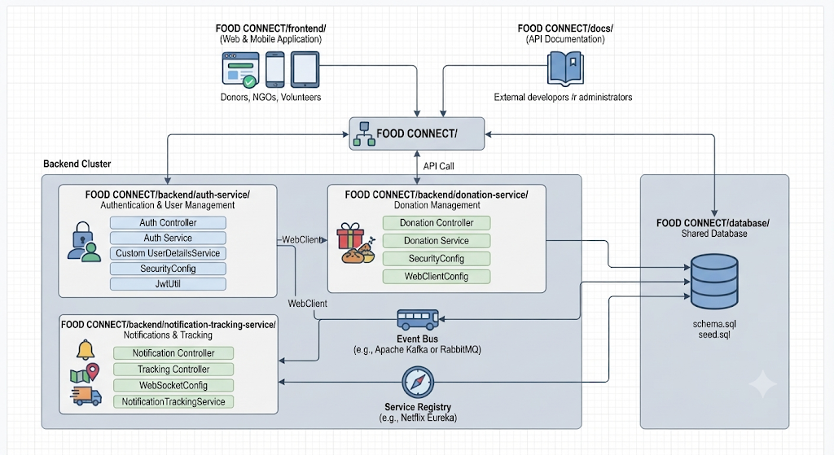

Description of Each Layer (Frontend, Backend, Database)
4.2.1 User Layer
The user layer represents the different types of users who interact with the Food Connect application.
Donor
Donors can provide information about available food donations and manage their donation activities through the application.
NGO
NGOs can view relevant food donations, manage their requirements, and coordinate the collection and distribution process.
Volunteer
Volunteers participate in the pickup and delivery process. Their activities can be tracked through the notification and tracking functionality.
Administrator
The administrator is responsible for managing and monitoring important application activities and users.
4.2.2 Front-End Layer
The front-end layer provides the graphical user interface through which users interact with the system.
The Food Connect frontend is developed using:
- React 19
- Vite
- Tailwind CSS
- React Router
- Axios
- Leaflet
- React-Leaflet
React components are used to create reusable user-interface elements. React Router manages navigation between different pages, while Axios communicates with the backend REST APIs.
Leaflet and React-Leaflet support map-based functionality for location-related operations.
The frontend runs independently from the backend and communicates with backend services through APIs.
4.2.3 Backend Layer
The backend follows a microservice architecture. Major application functions are separated into independent services.
Authentication Service
The Authentication Service manages:
- User registration
- User login
- Authentication
- Authorization
- User roles
- JWT token management
- User profile-related operations
The service uses Spring Boot, Spring Security, JWT, Spring Data JPA, and Hibernate.
Donation Service
The Donation Service manages the food donation functionality of the system.
Its responsibilities include:
- Creating donations
- Viewing donations
- Updating donation information
- Managing donation status
- Processing donation-related requests
- Storing donation information
The service communicates with the MySQL database using Spring Data JPA and Hibernate.
Notification and Tracking Service
The Notification and Tracking Service manages communication and tracking-related functionality.
It uses:
- Spring Boot
- WebSocket
- STOMP
- SockJS
This service allows real-time information to be communicated to users without requiring continuous manual page refreshes.
4.2.4 Database Layer
The database layer uses MySQL as the relational database management system.
The database stores application information such as:
- User information
- Authentication-related information
- Donor information
- NGO information
- Volunteer information
- Food donation information
- Donation status
- Tracking information
- Notification information
The backend services access the database using Spring Data JPA and Hibernate.
The React frontend does not directly access the database. All database operations are performed through the backend services.
4.2.5 Communication Layer
Two major communication mechanisms are used in Food Connect.
REST API Communication
REST APIs are used for normal client-server operations.
React Frontend
│
│ HTTP Request
▼
Spring Boot Service
│
│ Database Operation
▼
MySQL
Axios is used by the React frontend to send requests to the backend.
WebSocket Communication
WebSocket is used when real-time communication is required.
Spring Boot Backend
│
│ WebSocket
│ STOMP
▼
React Frontend
│
▼
Real-time Notification / Tracking
STOMP provides messaging functionality over WebSocket, while SockJS provides additional browser communication support.

Deployment Architecture (Cloud, Local, CI/CD Pipelines)

The Food Connect application is designed to run as separate frontend and backend components.
Local Development Deployment
During development, the architecture can be represented as:
LOCAL COMPUTER
│
┌────────────────┼────────────────┐
│ │ │
▼ ▼ ▼
React Frontend Spring Boot MySQL Server
Port: 5173 Services Port: 3306
│
┌────────────┼────────────┐
│ │ │
▼ ▼ ▼
Auth Donation Notification
:8081 :8082 :8083
Main Ports
Component | Port
React Frontend | 5173
Authentication Service | 8081
Donation Service | 8082
Notification & Tracking Service | 8083
MySQL | 3306
The frontend is accessed through the browser, while each backend microservice runs independently on its assigned port.

Deployment Flow
Browser
│
▼
React Frontend
Port 5173
│
┌────────────┼────────────┐
│ │ │
▼ ▼ ▼
Auth API Donation API Tracking API
:8081 :8082 :8083
│ │ │
└────────────┼──────────────┘
│
▼
MySQL Server
:3306
Deployment Characteristics
The architecture provides the following characteristics:
- Modularity – Authentication, donation, and tracking functionality are separated into different services.
- Independent Services – Each Spring Boot service can be developed and executed independently.
- API-Based Communication – The frontend communicates with backend services through REST APIs.
- Real-Time Communication – WebSocket, STOMP, and SockJS support real-time notifications and tracking.
- Centralized Data Storage – MySQL provides persistent storage for application data.
- Security – Spring Security and JWT are used to protect authenticated resources.
- Responsive Interface – React and Tailwind CSS provide the user-facing application.
Overall Architecture Summary
The Food Connect system follows a React + Spring Boot Microservices + MySQL architecture. The React frontend provides the user interface, while the three Spring Boot services handle authentication, food donation management, and notification/tracking functionality. MySQL provides persistent data storage, REST APIs provide standard communication, and WebSocket-based communication supports real-time functionality. This architecture separates major responsibilities while allowing all components to work together as a single food donation and NGO coordination platform.

CHAPTER -5 DESIGN

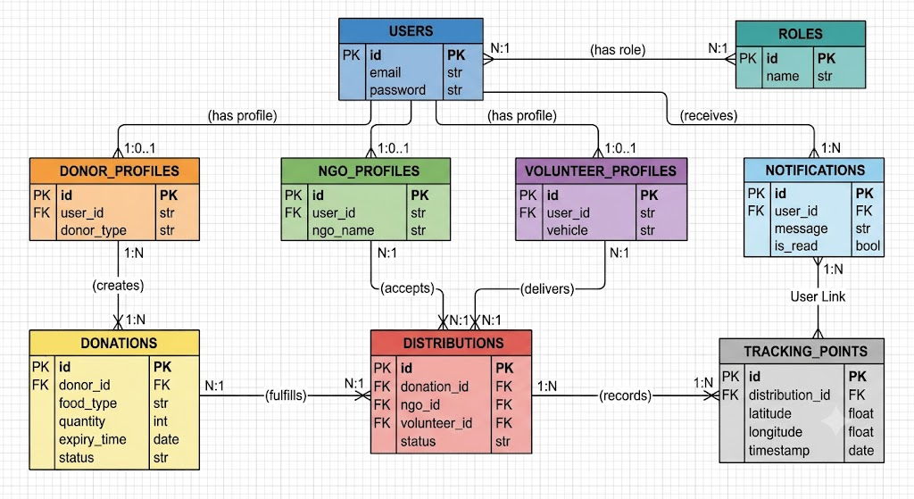

CHAPTER -6 IMPLEMENTATION

Section 6.1 – Module-Wise Implementation
The Food Connect application is divided into the following major functional modules:
6.1.1 User Authentication Module
The authentication module manages registration, login, user sessions, and role-based access.
The system supports the following user roles:
- Donor
- NGO
- Volunteer
- Administrator
Users can register through the registration page and subsequently log in using their credentials. After successful authentication, the backend generates an access token that is used for accessing protected resources.
The authentication service is implemented using Spring Boot, Spring Security, JWT, Spring Data JPA, and MySQL.
6.1.2 Donor Module
The donor module allows food donors to manage their food donation activities.
Major functions include:
- Donor dashboard
- Creating food donations
- Viewing donation information
- Monitoring donation status
- Viewing donation history
- Tracking assigned pickup activities
- Viewing notifications
- Accessing live tracking where applicable
The donor dashboard is implemented as a React component and communicates with the Donation Service through REST APIs.
6.1.3 NGO Module
The NGO module provides functionality for organizations that receive and distribute donated food.
The NGO dashboard supports activities such as:
- Viewing available donations
- Managing donations associated with the NGO
- Coordinating food collection
- Assigning volunteers
- Updating donation status
- Recording food distribution
- Viewing notifications
- Monitoring tracking information
The NGO functionality communicates with the Donation Service and Notification & Tracking Service through APIs.
6.1.4 Volunteer Module
The volunteer module supports the collection and transportation of donated food.
Major functions include:
- Viewing assigned pickup tasks
- Accepting assigned tasks
- Updating donation status
- Sending location information
- Viewing tracking information
- Receiving notifications
- Monitoring pickup and delivery progress
The volunteer location can be communicated to the tracking service through REST or WebSocket communication.
6.1.5 Administrator Module
The administrator module provides administrative management functionality.
The administrator can access:
- User information
- Donation information
- Platform statistics
- Donation status
- User-related information
- System monitoring functionality
Administrative APIs are protected using role-based authorization so that administrator-specific operations are not accessible to normal users.
6.1.6 Donation Management Module
The Donation Service manages the complete lifecycle of a food donation.
The implementation supports operations such as:
Create Donation
↓
Donation Available
↓
NGO / Volunteer Coordination
↓
Pickup
↓
Status Updates
↓
Distribution
↓
Completion
The system also maintains a donation status history, allowing previous status changes to be retrieved.
6.1.7 Notification Module
The notification module provides users with application notifications.
Users can:
- View notifications
- View unread notifications
- Check unread notification count
- Mark an individual notification as read
- Mark all notifications as read
The Notification & Tracking Service provides the corresponding REST APIs.
6.1.8 Live Tracking Module
The live tracking module is used to record and retrieve the location of donation collection or delivery activities.
The system supports:
- Recording location coordinates
- Retrieving the complete tracking trail
- Retrieving the latest location
- Live location updates through WebSocket
- Map-based visualization using Leaflet
The tracking service stores tracking points and provides them to the frontend when required.

Section 6.2 – Front-End Logic (UI Rendering and State Management)
The front-end is implemented using React 19 with Vite. React components are used to create the different pages and dashboards of the Food Connect system.
UI Rendering
The application uses React components for rendering the user interface.
The major pages include:
- Landing Page
- Login
- Registration
- Donor Dashboard
- NGO Dashboard
- Volunteer Dashboard
- Admin Dashboard
- Live Tracking
React Router is used to control navigation between these pages.
The application defines routes such as:
/
├── /login
├── /register
├── /donor
├── /ngo
├── /volunteer
├── /admin
└── /tracking/:id
The dashboards are protected according to the authenticated user's role.
State Management
The application uses React's state-management features, particularly:
- useState
- useEffect
- useContext
The AuthContext maintains the current authentication state.
The authentication context stores information such as:
- Current user
- Loading state
- Login status
- Registration status
The authentication token is stored in the browser's local storage after successful login or registration.
A simplified flow is:
User Login
↓
Backend Authentication API
↓
JWT Access Token
↓
localStorage
↓
AuthContext
↓
Protected Dashboard
The application also contains a NotificationContext for notification-related state and a PopupManager for application notifications and popup messages.
Role-Based UI Rendering
The application checks the user's role before allowing access to protected dashboards.
The supported routes include:
DONOR → /donor
NGO → /ngo
VOLUNTEER → /volunteer
ADMIN → /admin
If an unauthenticated user attempts to access a protected page, the application redirects the user to the login page.
If an authenticated user attempts to access a dashboard belonging to another role, the application redirects the user to the dashboard corresponding to their actual role.

6.3 API Integration

The React frontend communicates with the Spring Boot backend through REST APIs.
Axios is used for API communication.
The frontend creates separate Axios instances for the three backend services:
Frontend
│
├── Authentication API
│
├── Donation API
│
└── Tracking API
The API base URLs are configured using Vite environment variables:
VITE_AUTH_API_URL
VITE_DONATION_API_URL
VITE_TRACKING_API_URL
Authentication API
The authentication API provides operations including:
- User registration
- User login
- Token refresh
- Current user profile
- User information
- Volunteer information
Example API flow:
React Login Form
↓
POST /api/auth/login
↓
Authentication Service
↓
JWT Token
↓
React Application

Donation API
The frontend communicates with the Donation Service for operations such as:
- Creating donations
- Retrieving donations
- Updating donation status
- Assigning volunteers
- Accepting volunteer tasks
- Viewing donation history
- Recording distributions
- Retrieving donation information

Tracking API
The Tracking Service provides APIs for:
- Recording location
- Retrieving tracking history
- Retrieving latest location
- Getting notifications
- Getting unread notifications
- Marking notifications as read
The frontend also communicates with the tracking service using WebSocket for real-time location and notification functionality.

JWT Request Interceptor
The Axios configuration contains a request interceptor.
Before a request is sent, the application checks whether a JWT token is available in local storage.
If a token exists, it is added to the request:
Authorization: Bearer <JWT_TOKEN>
This allows protected backend APIs to identify and authenticate the requesting user.

6.4 Authentication and Authorisation
Authentication and authorization are implemented using Spring Security and JWT.
Authentication Process
The complete login process is:
1. User enters username/email and password
↓
2. React sends login request
↓
3. Authentication Service validates credentials
↓
4. Spring Security authenticates user
↓
5. Backend generates JWT access token
↓
6. Token is returned to React
↓
7. React stores token in localStorage
↓
8. Token is attached to future API requests

Registration
New users can register through the registration page.
The registration request is sent to:
POST /api/auth/register
The authentication service validates the submitted information and creates the corresponding user account.
The application supports registration for:
- Donors
- NGOs
- Volunteers

Login
Existing users log in through:
POST /api/auth/login
After successful authentication, the server returns an authentication response containing the access token and user information.
The frontend stores the access token and updates the authentication context.

JWT Authorization
The JWT token is used to access protected resources.
The process is:
React Application
│
│ Authorization: Bearer JWT
▼
Spring Security
│
├── Validate Token
│
├── Identify User
│
└── Check Role
│
▼
Protected API

Role-Based Authorization
The system uses role-based authorization to restrict sensitive operations.
Examples include:
Operation | Authorized Role
User registration | Public
User login | Public
Create donation | Donor
Accept pickup task | Volunteer
Update donation status | NGO / Volunteer / Admin
Record distribution | NGO / Volunteer
View all users | Admin
View all donations | Admin
Platform statistics | Admin
Spring Security's authorization mechanisms such as @PreAuthorize are used to enforce these restrictions at the backend level.
Protected Front-End Routes
The React application also performs front-end route protection using a ProtectedRoute component.
User
↓
Is user authenticated?
├── No → Login Page
│
└── Yes
↓
Check User Role
↓
Correct Dashboard
This provides an additional layer of user-interface protection, while the backend remains responsible for enforcing actual API authorization.

Overall Implementation Flow
USER
│
▼
React Frontend
│
┌────────┴────────┐
│ │
REST API WebSocket
│ │
▼ ▼
Spring Boot Notification &
Microservices Tracking Service
│
┌───────┼────────┐
│ │ │
▼ ▼ ▼
Auth Donation Tracking
Service Service Service
│ │ │
└───────┼────────┘
▼
MySQL
Implementation Summary
The Food Connect implementation combines React-based UI rendering, React state/context management, REST API integration, Spring Boot microservices, JWT authentication, Spring Security authorization, MySQL persistence, and WebSocket-based real-time tracking. The modular implementation allows each major function—authentication, donations, notifications, and tracking—to be maintained separately while providing a unified interface to donors, NGOs, volunteers, and administrators.

CHAPTER 7- FEATURES

List of Main Features
The major features implemented in the Food Connect system are:
- User Registration and Login
- Role-Based User Management
- Donor Dashboard
- Food Donation Posting
- Food Donation Status Tracking
- NGO Dashboard and Donation Management
- Volunteer Pickup and Delivery Management
- Nearby NGO Matching
- Real-Time Notifications
- Live GPS Tracking
- Pickup and Delivery OTP Verification
- Food Safety Countdown Timer
- Donation History and Status History
- Impact Certificate Generation
- Admin Dashboard
- Donation Statistics and Monitoring
- User Management
- Map-Based Location Visualization
- JWT Authentication and Role-Based Authorization
- Responsive Web Interface

How Each Feature Works

7.2.1 User Registration and Login
User Perspective
A new user can register by selecting the appropriate role:
- Donor
- NGO
- Volunteer
The registration form collects the required user and profile information. Existing users can enter their credentials through the login page.
After successful login, the user is directed to the dashboard associated with their role.
Technical Description
The React frontend sends registration and login requests to the Authentication Service.
Registration/Login
↓
React Frontend
↓
Authentication API
↓
Spring Boot Auth Service
↓
MySQL
↓
JWT Authentication Response
Spring Security validates credentials and JWT is used for authenticated API requests.

7.2.2 Role-Based User Management
User Perspective
Different users receive different dashboards and functionality according to their role.
Role | Main Functions
Donor | Post and monitor food donations
NGO | View and manage available donations
Volunteer | Accept pickup/delivery tasks and update progress
Admin | Monitor users, donations, and system statistics
Technical Description
The user's role is stored as part of the authentication information. The frontend uses protected routes, while Spring Security performs authorization on backend APIs.
This prevents users from directly accessing functions intended for another role.

7.2.3 Donor Dashboard
User Perspective
After login, donors can access their personal dashboard. They can:
- Post food donations
- View their existing donations
- Check donation status
- View pickup information
- View assigned NGO information
- Track active donations
- View pickup OTP
- Access impact certificates for completed donations
Technical Description
The DonorDash React component manages the donor interface. It communicates with the Donation Service through Axios-based REST APIs.
Donation information is retrieved from the backend and displayed dynamically using React state.

7.2.4 Food Donation Posting
User Perspective
A donor can post surplus food by entering information such as:
- Food details
- Quantity
- Food type/category
- Pickup address
- Additional instructions
- Expiry information
After submission, the donation becomes available for further processing by NGOs and volunteers.
Technical Description
The React donation form sends the donation information to the Donation Service through a REST API.
Donor
↓
Donation Form
↓
Axios POST Request
↓
Donation Service
↓
Validation
↓
MySQL
The backend stores the donation and generates the relevant donation status and verification information.

7.2.5 Donation Status Tracking
User Perspective
Users can monitor the progress of a donation from creation through pickup and delivery.
The project contains statuses such as:
Donation Created
↓
Accepted by NGO
↓
Volunteer Assigned
↓
Pickup in Progress
↓
Picked Up
↓
Out for Distribution
↓
Reached NGO
↓
Distributed
Expired or cancelled donations can also be represented by corresponding statuses.
Technical Description
The Donation Service maintains the donation status. The frontend retrieves the current status and displays it using status indicators.
A donation's status history can also be retrieved through the backend API.

7.2.6 NGO Dashboard
User Perspective
NGOs can access a dedicated dashboard for managing food donations.
The NGO can:
- View available donations
- Claim/accept suitable donations
- View donation information
- Coordinate volunteers
- Monitor pickup and delivery
- View donation status
- Receive notifications
Technical Description
The NgoDash React component communicates with the Donation Service through REST APIs.
When an NGO accepts a donation, the backend updates the donation status and the subsequent volunteer assignment and tracking processes can be initiated.

7.2.7 Volunteer Pickup and Delivery
User Perspective
Volunteers can view food pickup tasks assigned to them.
The volunteer can:
- Receive a pickup assignment.
- Accept the task.
- Travel to the pickup location.
- Verify the pickup using an OTP.
- Transport the food.
- Reach the NGO.
- Verify delivery using another OTP.
- Complete the delivery.
Technical Description
The Volunteer Dashboard retrieves assignments from the Donation Service.
The volunteer can accept a task using the corresponding API. Once accepted, the application can navigate the volunteer to the live tracking page.
WebSocket subscriptions are also used to receive assignment and donation updates in real time.

7.2.8 Nearby NGO Matching
User Perspective
When a donor posts surplus food, the system can identify relevant NGOs near the donation location.
The application is designed around location-based matching so that food can be collected and distributed efficiently.
Technical Description
The application uses location information such as latitude and longitude associated with donors, NGOs, and donations.
The project frontend also supports real-time notification of relevant donation activity through WebSocket communication.
The landing page describes an NGO matching radius of 10 km for the notification workflow.

7.2.9 Real-Time Notifications
User Perspective
Users can receive notifications about important activities such as:
- New pickup assignments
- Donation updates
- Status changes
- Tracking updates
- Other relevant system events
The notification interface also allows users to identify unread notifications.
Technical Description
The application uses:
- WebSocket
- STOMP
- SockJS
- Spring Boot
- React Notification Context
The frontend maintains notification state through NotificationContext.
The backend publishes events through WebSocket topics, allowing connected clients to receive updates without repeatedly refreshing the page.

7.2.10 Live GPS Tracking
User Perspective
Users can select Track Live GPS for an active donation.
The tracking page displays:
- Pickup location
- NGO/drop-off location
- Volunteer/collector location
- Route
- Movement history
- Current tracking information
This allows users to monitor the food movement from pickup toward the destination.
Technical Description
The Live Tracking page uses React-Leaflet to display an interactive map.
Tracking coordinates are retrieved from the Tracking Service.
Volunteer Location
↓
Tracking Service
↓
WebSocket
↓
LiveTracking.jsx
↓
Leaflet Map
↓
Real-Time Location Display
The project also uses an OSRM-based route calculation to display the route between pickup and NGO locations.

7.2.11 Pickup and Delivery OTP Verification
User Perspective
The system uses a 4-digit OTP to verify important handover operations.
During pickup, the donor provides the pickup OTP to the volunteer/collector.
During delivery, the NGO provides the delivery OTP to confirm that the food has been handed over.
Technical Description
The volunteer dashboard opens an OTP verification interface when the volunteer attempts to change relevant donation statuses.
The backend validates the submitted OTP before allowing the corresponding status transition.
This provides a verification mechanism for the pickup and delivery stages.

7.2.12 Food Safety Countdown Timer
User Perspective
The donor and volunteer dashboards can display a countdown associated with the food donation's expiry time.
This helps users identify donations that need to be handled within the available food-safety period.
Technical Description
The project contains a reusable FoodSafetyTimer React component.
It receives the donation's expiry information and dynamically displays the remaining time.
The timer is rendered within donation cards on the relevant dashboards.

7.2.13 Donation History
User Perspective
Users can view previously created donations and their current or completed status.
For an active donation, users can see its current stage. Completed donations can show their delivery/distribution information.
Technical Description
The Donation Service provides endpoints for retrieving donation information and status history.
The frontend requests this information through Axios and renders the results using React components.

7.2.14 Impact Certificate
User Perspective
After a donation reaches the appropriate completed/distributed stage, the donor can access an Impact Certificate.
The certificate provides information about the donor's contribution and the impact associated with the completed donation.
Technical Description
The project contains an ImpactCertificateModal React component.
The component receives completed donation information and presents it as an impact certificate that can be viewed/downloaded by the donor.

7.2.15 Administrator Dashboard
User Perspective
The administrator receives a centralized dashboard for monitoring the platform.
The dashboard contains sections for:
- Overview
- Donations
- Users
The overview provides system statistics.
Technical Description
The Admin Dashboard communicates with both the Authentication Service and Donation Service.
It retrieves:
- Donation statistics
- Donation records
- User information
The dashboard displays statistics such as:
- Total donations
- Distributed donations
- Active donations
- NGOs
- Expired/cancelled donations
- User counts by role

7.2.16 Donation Statistics
User Perspective
Administrators can view overall platform statistics to understand donation activity.
For example, the dashboard displays counts for total, active, distributed, and expired/cancelled donations.
Technical Description
The Donation Service provides an administrative statistics endpoint:
GET /donations/admin/stats
The React Admin Dashboard retrieves this information and displays it using statistical cards.

7.2.17 User Management
User Perspective
Administrators can view registered users and their roles.
The system identifies users according to roles such as:
- Donor
- NGO
- Volunteer
- Admin
Technical Description
The Admin Dashboard retrieves user information from the Authentication Service and renders the results in a user-management table.
Role information is displayed using different interface indicators.

7.2.18 Map-Based Location Visualization
User Perspective
Users can view relevant donation and pickup/delivery locations on an interactive map.
The map can display:
- Food pickup location
- NGO location
- Volunteer location
- Route
- Tracking trail
Technical Description
The system uses:
- Leaflet
- React-Leaflet
- OpenStreetMap map tiles
- OSRM route calculation
The map dynamically adjusts its view according to the available location markers and tracking points.

7.2.19 Authentication and Authorization
User Perspective
Users only see the dashboard and functionality associated with their account role.
For example, a volunteer cannot access the donor dashboard as a normal user.
Technical Description
Authentication is implemented using:
- Spring Security
- JWT
- JWT Authentication Filter
- Role-based authorization
The frontend stores the JWT and includes it in authenticated API requests.
Login
↓
JWT Generated
↓
Token Stored
↓
Authorization Header
↓
Spring Security
↓
JWT Validation
↓
Role Verification
↓
Protected Resource

7.2.20 Responsive User Interface
User Perspective
Food Connect provides a responsive interface that adapts to different screen sizes.
The dashboards, navigation elements, forms, cards, maps, and status information are designed to remain usable across desktop and smaller screens.
Technical Description
The interface is implemented using React and Tailwind CSS. Components are structured using responsive utility classes and reusable React components.

CHAPTER -8 TESTING

Postman Testing (Frontend/Backend)

Postman is used to test the REST APIs provided by the Food Connect backend services.
The frontend does not communicate directly with MySQL. Instead, the communication follows:
React Frontend
↓
Axios
↓
REST API
↓
Spring Boot Microservice
↓
MySQL Database
Postman can be used to test the same backend APIs independently of the React frontend.
Authentication API Testing
The Authentication Service runs on port 8081.
Important endpoints include:
Method | Endpoint | Purpose
POST | /api/auth/register | Register a new user
POST | /api/auth/login | Authenticate a user
POST | /api/auth/refresh | Refresh authentication token
GET | /api/auth/me | Retrieve current user information
GET | /api/auth/users | Retrieve users
GET | /api/auth/users/{id} | Retrieve a specific user
Example Login Request
{
"email": "user@example.com",
"password": "password"
}
A successful login returns an authentication response containing the JWT access token and user information.
The token can subsequently be used in Postman through the authorization header:
Authorization: Bearer <JWT_TOKEN>

Donation API Testing
The Donation Service runs on port 8082.
The API supports operations including:
Method | Endpoint | Purpose
POST | /api/donations | Create a donation
GET | /api/donations | Retrieve donations
GET | /api/donations/my | Retrieve user's donations
GET | /api/donations/{id} | Retrieve a particular donation
PUT | /api/donations/{id}/accept | Accept a donation
PUT | /api/donations/{id}/assign-volunteer | Assign volunteer
PUT | /api/donations/{id}/accept-task | Accept volunteer task
PUT | /api/donations/{id}/status | Update donation status
GET | /api/donations/{id}/history | Retrieve status history
POST | /api/donations/{id}/distribution | Record distribution
GET | /api/donations/{id}/distribution | Retrieve distribution information
The response status, response body, authentication, and database changes are checked during API testing.

Notification API Testing
The Notification & Tracking Service runs on port 8083.
Notification endpoints are tested for:
- Retrieving notifications
- Retrieving unread notifications
- Marking notifications as read
- Marking all notifications as read
Example operations include:
GET /api/notifications
GET /api/notifications/unread
PUT /api/notifications/{id}/read
PUT /api/notifications/read-all

Tracking API Testing
Tracking APIs are tested to verify that location information is correctly sent to and retrieved from the backend.
The tests include:
- Sending tracking coordinates
- Retrieving tracking history
- Retrieving the latest location
- Verifying donation-related tracking information
The expected flow is:
Postman
↓
Tracking API
↓
Tracking Service
↓
Database
↓
Tracking Response

Integration Testing
Integration testing verifies that the individual modules of Food Connect work correctly when connected together.
The major integration points are:
React Frontend
│
▼
Authentication Service
│
▼
Donation Service
│
▼
Notification & Tracking Service
│
▼
MySQL Database
8.2.1 Frontend–Authentication Integration
The registration and login pages are tested with the Authentication Service.
Registration Form
↓
Auth API
↓
User Creation
↓
MySQL
↓
Registration Response
For login:
Login Form
↓
Auth API
↓
Credential Validation
↓
JWT Token
↓
React Authentication Context
↓
User Dashboard

8.2.2 Frontend–Donation Service Integration
The donor creates a donation through the React interface.
The information is sent to the Donation Service through Axios.
Donor Dashboard
↓
Donation Form
↓
POST Donation API
↓
Donation Service
↓
MySQL
↓
Donation Response
↓
Updated Dashboard
This verifies that the frontend form, API, backend service, and database operate together.

8.2.3 Donation–Volunteer Integration
The donation workflow is tested from creation to volunteer assignment.
Donor Creates Donation
↓
NGO Accepts Donation
↓
Volunteer Assigned
↓
Volunteer Accepts Task
↓
Pickup
↓
Delivery
Each status transition is checked to ensure that the correct information is maintained between the frontend and backend.

8.2.4 Notification Integration
When an important donation event occurs, the notification service is used to communicate the update to the relevant user.
Donation Event
↓
Notification Service
↓
WebSocket / STOMP
↓
React Notification Context
↓
Notification Display
This integration verifies that notifications are generated and displayed correctly.

8.2.5 Live Tracking Integration
The live tracking functionality integrates the volunteer location, tracking service, WebSocket communication, and map interface.
Volunteer
↓
Location Data
↓
Tracking Service
↓
WebSocket
↓
React Tracking Page
↓
Leaflet Map
The integration test verifies that tracking information is correctly transmitted and displayed on the map.

8.2.6 Database Integration
The Spring Boot services are integrated with MySQL through Spring Data JPA and Hibernate.
The following operations are tested:
- Insert
- Retrieve
- Update
- Delete where applicable
- Status updates
- User information
- Donation information
- Tracking information
- Notification information
The database is checked after important API operations to verify that the expected data is persisted correctly.

Tools Used for Testing

Testing was carried out to verify the correctness, reliability, security, and functionality of the Food Connect application. Different test cases were prepared for the major modules, including user registration, authentication, food donation, NGO management, volunteer activities, notifications, tracking, and administrative functions.
Each test case contains an input or action performed by the user, the expected system behaviour, and the actual result obtained during testing. Both valid and invalid inputs were considered to ensure that the application handles normal operations as well as incorrect or unauthorized requests.
User Authentication Test Cases
The registration functionality was tested by entering valid user information. The system successfully validated the details and created the user account. Duplicate registration was also tested to ensure that an existing account could not be registered again.
The login functionality was tested using both valid and invalid credentials. With valid credentials, the user was authenticated and redirected to the appropriate dashboard. With incorrect credentials, the system displayed an appropriate authentication error.
JWT authentication was also tested by accessing protected APIs with and without a valid token. Requests containing a valid token were processed successfully, while unauthorized requests were rejected.
Food Donation Test Cases
The food donation module was tested by entering valid donation information through the donor dashboard. The system successfully accepted the information and stored the donation details in the database.
The donation retrieval functionality was tested to ensure that users could view their available and previously created donations. Donation status updates were also tested to verify that changes were correctly reflected in the application and database.
NGO and Volunteer Test Cases
The NGO functionality was tested by checking the availability of food donations and the ability to accept suitable donations. After accepting a donation, the corresponding donation status was updated correctly.
Volunteer functionality was tested by assigning volunteers to donation activities. The volunteer was able to view assigned tasks and update the relevant task or donation status.
Pickup and delivery verification were also tested using the OTP functionality. Valid OTPs were accepted by the system, while invalid OTPs were rejected.
Notification Test Cases
The notification module was tested by generating events that should produce notifications. Notifications were successfully retrieved from the notification service and displayed in the frontend.
Unread notifications were tested to ensure that they could be identified separately. The mark-as-read functionality was also tested to verify that notification status was updated correctly.
Tracking Test Cases
The tracking functionality was tested by providing valid location coordinates. The system successfully processed the tracking information and made the latest location and tracking history available to authorized users.
The map interface was also tested to verify that relevant locations and tracking information could be displayed correctly using the map component.
Admin Module Test Cases
The administrator dashboard was tested to verify that authorized administrators could access system statistics, user information, and donation information.
Unauthorized users were also tested against administrator-specific operations. These users were prevented from accessing restricted administrative functionality.
Test Results
Test Case | Expected Result | Actual Result | Status
User registration with valid details | Account should be created | Account created successfully | Pass
Registration with existing details | Duplicate account should be rejected | Registration rejected | Pass
Login with valid credentials | User should be authenticated | Login successful | Pass
Login with invalid credentials | Authentication should fail | Error displayed | Pass
Access protected API with valid JWT | Request should be accepted | Request accepted | Pass
Access protected API without JWT | Request should be rejected | Access rejected | Pass
Create food donation | Donation should be stored | Donation created successfully | Pass
View donation details | Donation information should be displayed | Information displayed | Pass
Accept donation by NGO | Donation status should change | Status updated | Pass
Assign volunteer | Volunteer should be assigned | Assignment successful | Pass
Update donation status | New status should be stored | Status updated | Pass
Verify pickup using valid OTP | Pickup should be verified | Verification successful | Pass
Verify delivery using valid OTP | Delivery should be verified | Verification successful | Pass
Retrieve notifications | Notifications should be displayed | Notifications displayed | Pass
Mark notification as read | Notification status should change | Status updated | Pass
Submit tracking location | Location should be stored | Location recorded | Pass
Retrieve tracking information | Tracking data should be displayed | Data displayed | Pass
Access admin dashboard | Authorized admin should access dashboard | Dashboard displayed | Pass
Unauthorized admin access | Access should be denied | Access denied | Pass
Store application data | Data should persist in MySQL | Data stored successfully | Pass
Testing Outcome
The testing process verifies the major functional requirements of the Food Connect application. The results demonstrate that the core modules, including authentication, donation management, NGO coordination, volunteer management, notifications, tracking, and administration, respond according to their intended functionality. API testing and database verification further ensure that communication between the React frontend, Spring Boot backend services, and MySQL database works correctly.

CHAPTER -9 DEPLOYMENT

Steps to Deploy
The Food Connect application can be deployed in a sequence that ensures all required components are configured correctly.
Step 1: Prepare the Source Code
The complete project source code is maintained in the project repository. Before deployment, the latest stable version of the frontend and backend source code is obtained and checked for compilation or build errors.
The project structure contains the frontend and backend components separately, making it possible to build and deploy them independently.
Step 2: Install Required Software
The deployment environment should have the required runtime and build tools installed. These include:
- Node.js and npm for the React frontend
- Java 17 or compatible Java runtime for Spring Boot
- Maven for building the backend services
- MySQL Server for database storage
- Git for obtaining the source code
The required software versions should be compatible with the versions specified in the project configuration files.
Step 3: Configure the Database
A MySQL database is created for the application. The required database name, username, password, host, and port are configured in the backend environment configuration.
The Spring Boot services are then connected to the MySQL database through their database configuration.
Step 4: Build the Backend Services
Each Spring Boot microservice is built separately using Maven.
The backend services include:
- Authentication Service
- Donation Service
- Notification and Tracking Service
Maven downloads the required dependencies and creates the executable application package.
Step 5: Configure the Frontend
The React application's environment configuration is updated with the URLs of the deployed backend services.
The frontend must know where to send:
- Authentication requests
- Donation requests
- Tracking requests
- Notification requests
After configuration, the React application is built into optimized production files.
Step 6: Deploy the Backend
The generated Spring Boot applications are started on the deployment server.
Each service is configured with its own port or deployment URL. The services must be able to communicate with the MySQL database and, where required, with each other.
Step 7: Deploy the Frontend
The production build generated by Vite is uploaded to a frontend hosting platform or web server.
The hosting service serves the React application's static files to users through a web browser.
Step 8: Test the Deployed Application
After deployment, the complete application is tested using the production URLs.
The following operations are verified:
- User registration
- Login
- JWT authentication
- Donation creation
- NGO operations
- Volunteer operations
- Notifications
- Tracking
- Map functionality
- Administrative functions
This final testing ensures that the frontend, backend, database, and communication services are correctly connected.

Environment Configuration
Environment configuration is used to store deployment-specific information separately from the application source code. This prevents sensitive information such as database passwords and authentication secrets from being directly written into application code.
The Food Connect application requires environment configuration for both the frontend and backend.
Backend Configuration
The backend services require configuration information such as:
- Server port
- Database URL
- Database username
- Database password
- JWT secret
- JWT expiration settings
- CORS configuration
- Service URLs
- WebSocket configuration
A typical backend configuration contains values similar to:
PORT=8081
DB_HOST=<database-host>
DB_PORT=3306
DB_NAME=<database-name>
DB_USERNAME=<database-username>
DB_PASSWORD=<database-password>
JWT_SECRET=<secure-secret>
The exact values are changed according to the deployment environment.
The three backend services can use different ports during local development, while cloud deployment may provide individual service URLs.
Frontend Configuration
The React frontend uses environment variables to identify the backend services.
Example configuration:
VITE_AUTH_API_URL=<authentication-service-url>
VITE_DONATION_API_URL=<donation-service-url>
VITE_TRACKING_API_URL=<tracking-service-url>
During local development, these values can point to localhost services.
During production, they are changed to the public URLs of the deployed backend services.
Security Considerations
Sensitive configuration values should not be committed to a public GitHub repository.
Important information such as:
- Database passwords
- JWT secrets
- API keys
- Private credentials
should be stored using the hosting platform's environment-variable or secret-management facilities.
This prevents unauthorized users from obtaining sensitive application credentials.

Hosting of Frontend and Backend

The Food Connect application follows a distributed hosting approach in which the frontend, backend microservices, and database can be hosted as separate components. This structure allows each part of the application to be managed independently while communicating through well-defined APIs.
Frontend Hosting
The frontend of Food Connect is developed using React and Vite. During development, the application can be executed locally using the Vite development server. For deployment, the React application is converted into optimized static files using the production build process.
The production frontend consists mainly of HTML, CSS, JavaScript, images, and other static resources. These files can be hosted on a static web hosting platform or a web server. When a user opens the Food Connect website, the browser downloads the frontend files and executes the React application.
The frontend communicates with the backend through REST API requests. The API URLs are configured using environment variables so that the same frontend code can be used in development and production environments.
For example, the application can use environment variables such as:
- VITE_AUTH_API_URL – URL of the Authentication Service
- VITE_DONATION_API_URL – URL of the Donation Service
- VITE_TRACKING_API_URL – URL of the Notification and Tracking Service
This approach prevents backend addresses from being hard-coded throughout the frontend application.
Backend Hosting
The backend of Food Connect is implemented using Spring Boot microservices. Instead of keeping all backend operations inside one application, the system separates major responsibilities into different services.
The main backend services are:
- Authentication Service – manages registration, login, JWT authentication, user details, and role-based access.
- Donation Service – manages food donations, donation status, NGO acceptance, volunteer assignment, pickup, and distribution.
- Notification and Tracking Service – handles notifications, real-time communication, and volunteer tracking.
During local development, these services run on separate ports. In a production environment, each service can be hosted on a server or cloud platform and accessed through its respective API URL.
The backend services should be configured with production environment variables for database connection details, JWT secrets, service URLs, CORS settings, and other required configuration values.
Database Hosting
Food Connect uses MySQL as its database. The database stores important application information such as user details, donation records, roles, donation status, volunteer assignments, notifications, and tracking-related information.
For local development, MySQL can run on the developer's computer. For production deployment, the database can be hosted on a managed database server or a dedicated database server.
The backend services connect to the production MySQL database using secure database credentials. Database credentials should not be written directly inside the source code. They should instead be provided through environment variables or secure configuration management.
Communication Between Components
After deployment, the different components communicate through network requests. The user's browser first loads the React frontend. The frontend then sends requests to the appropriate Spring Boot backend service.
For example, when a donor creates a food donation, the frontend sends the donation information to the Donation Service. The Donation Service processes the request and stores the information in MySQL. Similarly, authentication requests are sent to the Authentication Service, while tracking and notification operations communicate with the Notification and Tracking Service.
This separation improves modularity and makes it possible to update or maintain individual services without modifying the complete application.
Production Security
Security is an important part of hosting the Food Connect application. Production deployment should use HTTPS so that communication between users and the application is encrypted. JWT authentication is used to protect secured API endpoints, while role-based authorization prevents users from accessing functions that do not belong to their assigned role.
CORS configuration should also be updated for the production frontend domain. Sensitive values such as database passwords and JWT secrets should be stored as environment variables rather than committed to GitHub.
Deployment Verification
After hosting the frontend and backend, the complete application should be tested in the production environment. The following operations should be verified:
- Opening the Food Connect website.
- User registration and login.
- JWT-based authentication.
- Role-based dashboard access.
- Creating and managing donations.
- NGO acceptance of donations.
- Volunteer assignment and pickup.
- Donation status updates.
- Notifications and tracking.
- Database operations.
- API communication between frontend and backend.
- Mobile and desktop responsiveness.
Therefore, hosting the frontend, backend microservices, and MySQL database as connected components provides a complete deployment environment for the Food Connect system. It allows users to access the application through a web browser while the backend services securely process requests and maintain application data.

CHAPTER -10 CHALLENGES & LIMITATIONS

Issues Faced During Development
The development of the Food Connect platform involved several technical and design challenges because the system combines real-time communication, location tracking, authentication, database management, and multiple user roles.
1. Integration of Multiple Technologies
The project uses several technologies together, including React, Vite, Spring Boot, Spring Security, MySQL, WebSocket/STOMP, Leaflet, Axios and JWT. Integrating these technologies required careful configuration of APIs, ports, authentication headers, database connections and cross-origin requests.
The frontend communicates with three independent backend services. Therefore, a failure in one service can affect the functionality available to the user.
2. Microservice Communication
The backend is divided into:
- Authentication Service
- Donation Service
- Notification and Tracking Service
This separation improves modularity but introduces communication overhead. The services must correctly exchange information such as user identity, donation status and notification events.
For example, the Donation Service communicates with the Authentication Service and Notification/Tracking Service. Incorrect service configuration or an unavailable service can result in failed requests.
3. Real-Time Notification Handling
Food Connect requires NGOs and volunteers to receive updates without repeatedly refreshing the page. WebSocket and STOMP messaging were therefore used for real-time communication.
WebSocket provides a persistent two-way communication channel, while STOMP provides a messaging protocol on top of WebSocket.
Maintaining a reliable WebSocket connection can be challenging because network interruptions, browser restrictions and server availability can affect real-time updates.
4. Live GPS Tracking
Live tracking is one of the more technically demanding components of the project. The application obtains geographical coordinates and displays the movement of the volunteer/collector using Leaflet.
The system also maintains tracking points and displays the route between locations. Leaflet is designed for interactive, mobile-friendly maps and provides markers, polylines and other map functionality used by the application.
GPS accuracy can vary depending on the device, browser permissions, network conditions and environmental conditions.
5. Food Donation Status Management
A donation can pass through several states, such as:
- Posted
- Accepted by NGO
- Volunteer Assigned
- Pickup in Progress
- Picked Up
- Reached NGO
- Out for Distribution
- Distributed
- Expired
- Cancelled
Maintaining valid transitions between these states is important because an incorrect state can affect NGO, donor and volunteer dashboards.
6. Authentication and Authorization
Different users have different permissions. A donor should manage donations, an NGO should accept donations and assign volunteers, while a volunteer should manage assigned pickups.
JWT-based authentication and Spring Security were used to implement authentication and authorization. Spring Security provides authentication, authorization and protection mechanisms for Spring applications.
Implementing role-based access correctly across multiple services was therefore an important development challenge.
7. Database Relationships
The database contains multiple related entities such as users, roles, donor profiles, NGO profiles, volunteer profiles, donations, status histories, tracking points, notifications and distributions.
Maintaining foreign-key relationships and consistent records becomes increasingly important as the number of donations and users increases.
8. External Map and Routing Dependency
The live tracking component uses an external routing service to calculate routes. This introduces dependency on network connectivity and external service availability.
If the external routing service is unavailable, route information may not be calculated correctly even though the core application continues to operate.

Solutions Applied
1. Modular Microservice Architecture
The backend was divided into separate Spring Boot services. This makes the system modular and allows individual services to be developed and maintained independently.
Spring Boot supports stand-alone applications and provides features such as externalized configuration, production support and embedded servers.
2. REST API Communication
REST APIs were used between the frontend and backend services. Axios was used in the React application to send HTTP requests.
The frontend maintains separate API clients for authentication, donations and tracking, which keeps service communication organized.
3. JWT Authentication
JWT was selected for authentication because it allows authenticated requests to carry a signed token. JWT is a standardized method for transmitting claims between parties and is commonly used for authorization.
The frontend attaches the JWT to protected API requests using the Authorization: Bearer mechanism.
4. Role-Based Access Control
Different application roles were defined:
- Donor
- NGO
- Volunteer
- Admin
This ensures that users access functionality appropriate to their responsibilities.
5. WebSocket/STOMP Communication
WebSocket and STOMP were implemented for real-time notification and tracking updates.
The application uses subscriptions for donation and tracking-related topics so that connected users can receive updates without manually refreshing the page.
Spring provides support for STOMP over WebSocket and also supports SockJS as a fallback mechanism.
6. OTP-Based Verification
OTP verification was incorporated into important stages such as pickup and delivery. This adds an additional confirmation mechanism before changing critical donation states.
7. GPS Breadcrumb Storage
Tracking coordinates are stored as tracking points associated with a donation and collector. This allows the application to display the current position as well as the previous movement trail.
8. Database Indexing
Indexes were defined for frequently accessed fields such as:
- User email
- User role
- Donation status
- Donor ID
- NGO ID
- Donation coordinates
- Expiry time
- Notification recipient
- Tracking donation ID
Database indexing can reduce the amount of data that must be searched for frequently used queries. MySQL provides indexing and transaction mechanisms for improving database operations and consistency.

Current Limitations or Known Bugs
Although the Food Connect prototype provides the major functionality required for demonstrating the system, certain limitations remain.

1. Localhost-Based Deployment
The current configuration is primarily designed for local development. Backend services use localhost ports and the frontend expects development API endpoints.
Therefore, additional configuration is required before deploying the complete application to a public production environment.

2. Dependency on Internet Connectivity
Real-time notifications, map tiles and external routing require network connectivity. If the internet connection is interrupted, some features may become temporarily unavailable.

3. GPS Accuracy
The live tracking system depends on browser/device GPS capabilities. GPS coordinates may not always represent the exact physical position of a volunteer.

4. External Routing Dependency
Route calculation depends on an external routing service. This introduces a third-party dependency and may result in unavailable or delayed route information.

5. Limited Notification Channels
The current implementation primarily provides application-based notifications and real-time WebSocket updates. Dedicated SMS, WhatsApp or email notification services have not been integrated.

6. Development Configuration Contains Sensitive Values
The current project configuration contains development database credentials and JWT configuration directly in application properties. This is acceptable for a controlled academic prototype but should not be retained in the same form for production.
Production systems should use environment variables, secrets management and secure deployment configuration.

7. Browser-Based Token Storage
The frontend stores the authentication token in browser local storage. This simplifies the prototype implementation, but token storage requires additional security consideration in a production system. JWT guidance also recommends careful handling of tokens and warns against storing sensitive session information insecurely in browser storage.

8. Limited Automated Testing
The project primarily focuses on functional demonstration. A production version would require a more extensive automated testing strategy, including unit, integration, API, security and end-to-end tests.

9. Scalability of Real-Time Communication
The current WebSocket implementation is suitable for a prototype and controlled number of users. A large-scale deployment may require an external message broker and distributed WebSocket infrastructure.

CHAPTER -11 FUTURE ENHANCEMENTS

Planned Features
The following features can be added in future versions of Food Connect.
1. Mobile Application
A dedicated Android and iOS application can be developed for donors, NGOs and volunteers.
A mobile application would provide better access to GPS services and allow volunteers to update their location during transportation.
2. SMS and WhatsApp Notifications
The notification system can be expanded to include:
- SMS alerts
- WhatsApp notifications
- Email notifications
- Emergency alerts
This would allow users to receive important information even when they are not actively using the website.
3. Advanced NGO Verification
NGOs can be verified using registration documents and administrative approval.
A verification mechanism can improve trust between donors, NGOs and volunteers.
4. Improved Food Safety Management
Future versions can include:
- Food temperature records
- Food category restrictions
- Expiry warnings
- Storage-condition monitoring
- Food safety checklists
This would improve the safety of donated food.
5. Donation Analytics
The system can provide detailed analytics such as:
- Total food rescued
- Total meals provided
- Monthly donation statistics
- NGO performance
- Volunteer contribution
- Food waste reduction
- Geographic distribution of donations
6. Advanced Search and Filtering
Users could search donations based on:
- Food type
- Distance
- Quantity
- Expiry time
- Location
- Availability
- Donation status
This would make the matching process more efficient.
7. Automatic Matching
An intelligent matching system could automatically select the most appropriate NGO based on:
- Distance
- Service radius
- Current workload
- Food requirement
- Availability
- Previous acceptance history
This could reduce the time required to match donations.
8. Cloud Deployment
The complete system can be deployed using cloud infrastructure instead of localhost.
Potential deployment components include:
- Cloud-hosted frontend
- Cloud-hosted microservices
- Managed MySQL database
- Object storage
- Secure secret management
- Load balancing
- Monitoring

Possible Integrations or Optimisations

1. Message Broker Integration
A dedicated message broker such as RabbitMQ or Apache Kafka could be introduced for high-volume notification processing.
This would make the system more suitable for large-scale real-time communication.
2. Redis Caching
Redis can be used to cache frequently accessed information such as:
- NGO locations
- Available volunteers
- Donation availability
- User sessions
- Frequently accessed statistics
Caching can reduce unnecessary database queries.
3. Database Optimization
Further database optimization can include:
- Query optimization
- Additional indexes
- Pagination
- Connection pooling
- Database monitoring
- Archiving old tracking records
MySQL provides transaction and locking mechanisms that can be used to maintain consistency in concurrent database operations.
4. Improved Location Matching
Instead of basic radius calculations, a spatial database/indexing approach can be introduced for efficient geographical searches.
This would become increasingly useful when the number of donors and NGOs becomes large.
5. Artificial Intelligence-Based Prediction
Machine learning could be introduced to predict:
- Food donation demand
- High-demand locations
- Donation expiry risk
- Expected pickup time
- NGO requirements
Historical donation and distribution data could be used to train predictive models.
6. Image-Based Food Verification
Computer vision could potentially be used to analyze uploaded food images and identify inappropriate or potentially unsafe food items.
Such a system should be treated as an assistance mechanism rather than a replacement for human food-safety checks.
7. Production-Level Security
Future versions should introduce:
- HTTPS
- Environment-based secrets
- Stronger token management
- Refresh-token rotation
- Rate limiting
- API gateway
- Audit logging
- Security monitoring
8. Monitoring and Observability
The microservices can be integrated with monitoring tools to track:
- API response time
- Service failures
- Database performance
- WebSocket connections
- CPU and memory usage
- Error rates
This would simplify maintenance and troubleshooting.

CHAPTER -12 CONCLUSION

  - Summary of the Project
Food Connect is a centralized food donation management platform designed to connect food donors with NGOs and volunteers.
The system provides a digital environment where surplus food can be registered, accepted by NGOs, assigned to volunteers, collected from donors and finally distributed to beneficiaries.
The application implements a role-based architecture with separate functionality for Donors, NGOs, Volunteers and Administrators.
The major functionality implemented includes:
- User registration and login
- JWT-based authentication
- Role-based authorization
- Food donation creation
- Nearby NGO notification
- NGO donation acceptance
- Volunteer assignment
- Pickup and delivery verification
- Donation status management
- Real-time notifications
- GPS tracking
- Interactive maps
- Food distribution recording
- Administrative dashboard
- Donation and user statistics
The frontend is implemented using React and Vite, while the backend uses Spring Boot microservices and the data is stored in MySQL. Vite provides a modern development/build environment for frontend applications, including development-server and production-build capabilities.
The project demonstrates how different software engineering concepts can be combined to address a real-world problem involving food wastage and food distribution.

What Was Achieved
The project achieved the development of a functional prototype capable of managing the major stages of a food donation lifecycle.
Functional achievements
- Multi-user platform
Different users can interact with the system according to their assigned roles.
- Secure authentication
User authentication and authorization are implemented using JWT and Spring Security.
- Donation management
Donors can register surplus food with information such as food type, quantity, pickup location and expiry time.
- NGO matching
NGOs can view available donations and accept suitable donations based on their service area.
- Volunteer management
Volunteers can receive and manage pickup assignments.
- Real-time communication
WebSocket/STOMP is used for real-time updates.
- Location tracking
Leaflet-based maps are used to visualize pickup and delivery locations.
- OTP verification
OTP-based confirmation is used at important stages of the donation process.
- Distribution tracking
NGOs can record the final distribution of donated food.
- Administrative monitoring
Administrators can view platform-level users, donations and statistical information.

Skills Learned During Development

The development of Food Connect provided practical experience in several areas of software engineering.
Frontend Development
Experience was gained in:
- React
- JSX
- React components
- React Router
- React Context
- State management
- Axios API integration
- Responsive UI development
- Vite
React supports component-based application development and provides APIs and hooks for building interactive web applications.
Backend Development
The project provided experience with:
- Java
- Spring Boot
- Spring MVC
- REST APIs
- Spring Security
- JWT
- Microservices
- WebSocket
- STOMP
Database Management
Practical knowledge was developed in:
- MySQL
- Database design
- Relational tables
- Primary keys
- Foreign keys
- Constraints
- Indexing
- Transactions
- Entity relationships
Real-Time Systems
The project provided practical understanding of:
- WebSocket communication
- STOMP messaging
- Real-time notifications
- Live tracking
- Event-driven updates
Geographic Information Systems
The integration of Leaflet provided experience with:
- Maps
- Markers
- Coordinates
- Polylines
- GPS tracking
- Route visualization
Software Engineering
The project also improved understanding of:
- Modular architecture
- Microservices
- API design
- Authentication
- Authorization
- Error handling
- Database consistency
- Testing
- Debugging
- Deployment considerations
Overall, the project helped bridge the gap between theoretical software engineering concepts and their practical implementation in a full-stack application.

CHAPTER -13 REFERENCES

Books

- React Documentation – React official documentation for components, hooks and application development. React Documentation
- Vite Documentation – Official documentation for Vite development, configuration and production builds. Vite Documentation
- Spring Boot Documentation – Official Spring Boot documentation covering application development, configuration and deployment. Spring Boot Documentation
- Spring Security Documentation – Reference material for authentication, authorization and application security. Spring Security Documentation
- Spring WebSocket Documentation – Documentation for WebSocket and STOMP-based real-time communication. Spring WebSocket Documentation
- JSON Web Token Introduction – Reference for JWT structure, authentication and authorization. JWT Introduction
- MySQL Reference Manual – Reference for SQL, database management, indexing, transactions and locking. MySQL 8.4 Reference Manual
- Leaflet Documentation – Official documentation for interactive maps, markers, routes and map layers. Leaflet Documentation
APIs and Libraries Used
- Axios Documentation – Used for HTTP communication between the React frontend and backend APIs.
- Leaflet / React-Leaflet – Used for interactive map visualization and GPS tracking.
- STOMP.js – Used for client-side STOMP/WebSocket communication.
- Lucide React – Used for interface icons.
- Maven Documentation – Used for dependency management and building the Spring Boot backend services.
- MySQL – Used as the relational database management system for storing users, donations, notifications, tracking records and distribution information.

CHAPTER -14 APPENDICES

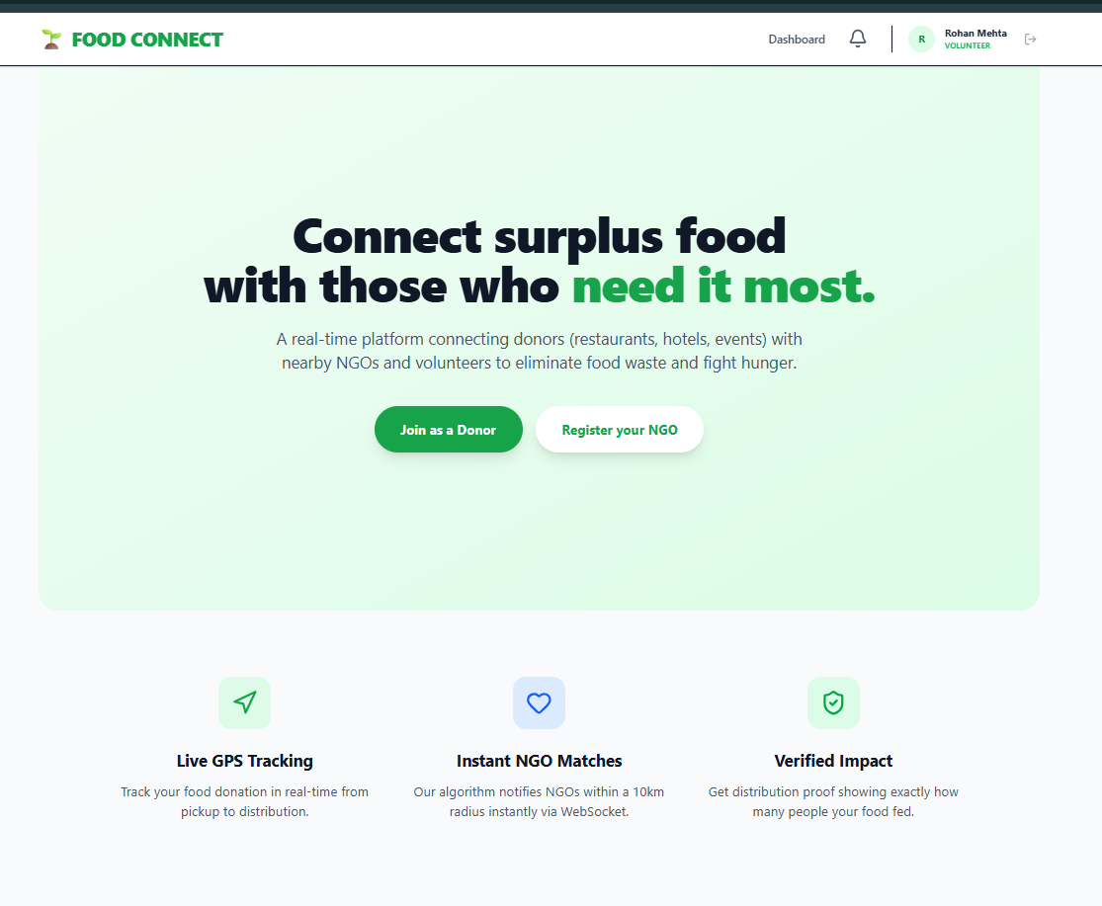
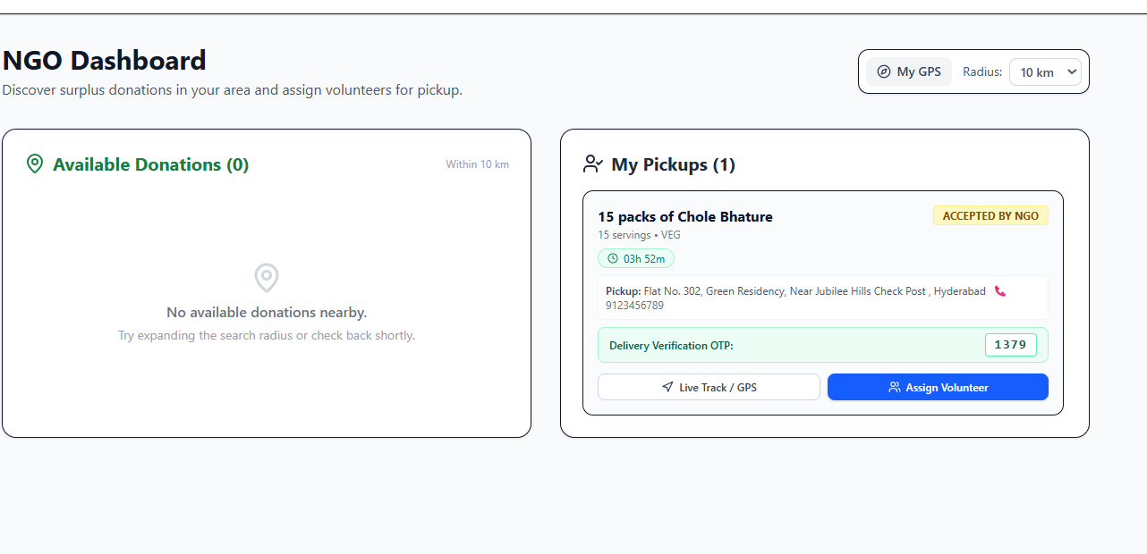

Screenshots of the app

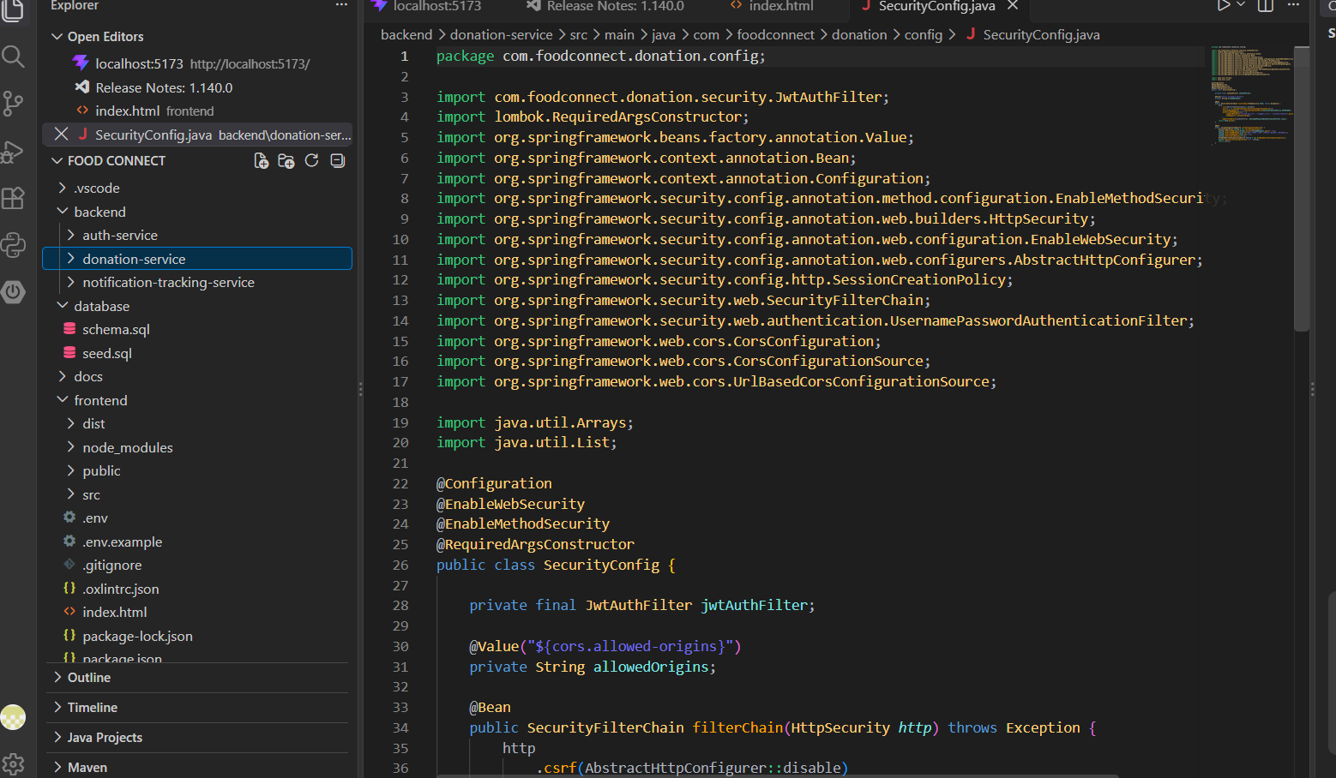

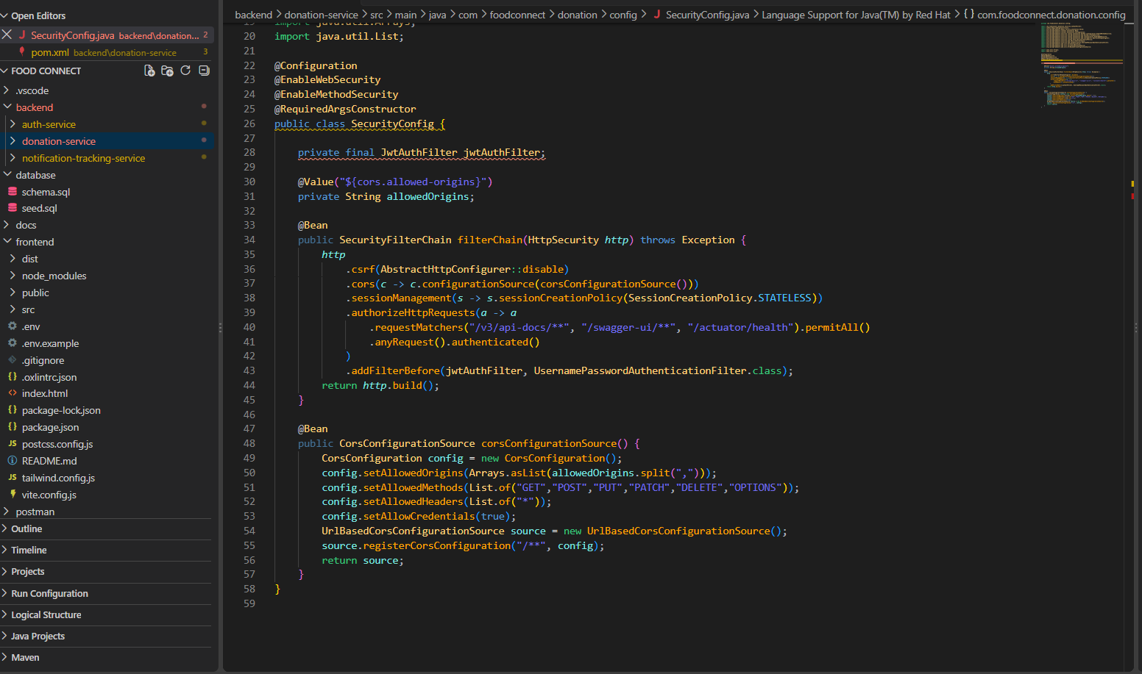

Sample code snippets

Installation/setup instructions

1. Prerequisites
Install the following:
- Java JDK 17
- Maven
- Node.js and npm
- MySQL
- VS Code
2. Database Setup
- Start MySQL.
- Create the food_connect database.
- Run schema.sql followed by seed.sql.
- Configure the MySQL username and password in the backend application.properties files.
3. Backend Setup
The project contains three Spring Boot services:
- Authentication Service – Port 8081
- Donation Service – Port 8082
- Notification & Tracking Service – Port 8083
Run each service using:
mvn spring-boot:run
4. Frontend Setup
Open the frontend folder and run:
npm install
npm run dev
The frontend will run at:
http://localhost:5173
5. Application Access
Open the application in a browser and log in using the demo accounts provided in the project’s seed.sql file.
System requirements: Java 17, Node.js, Maven, MySQL, and a modern web browser.

Geo Tag photos with guide
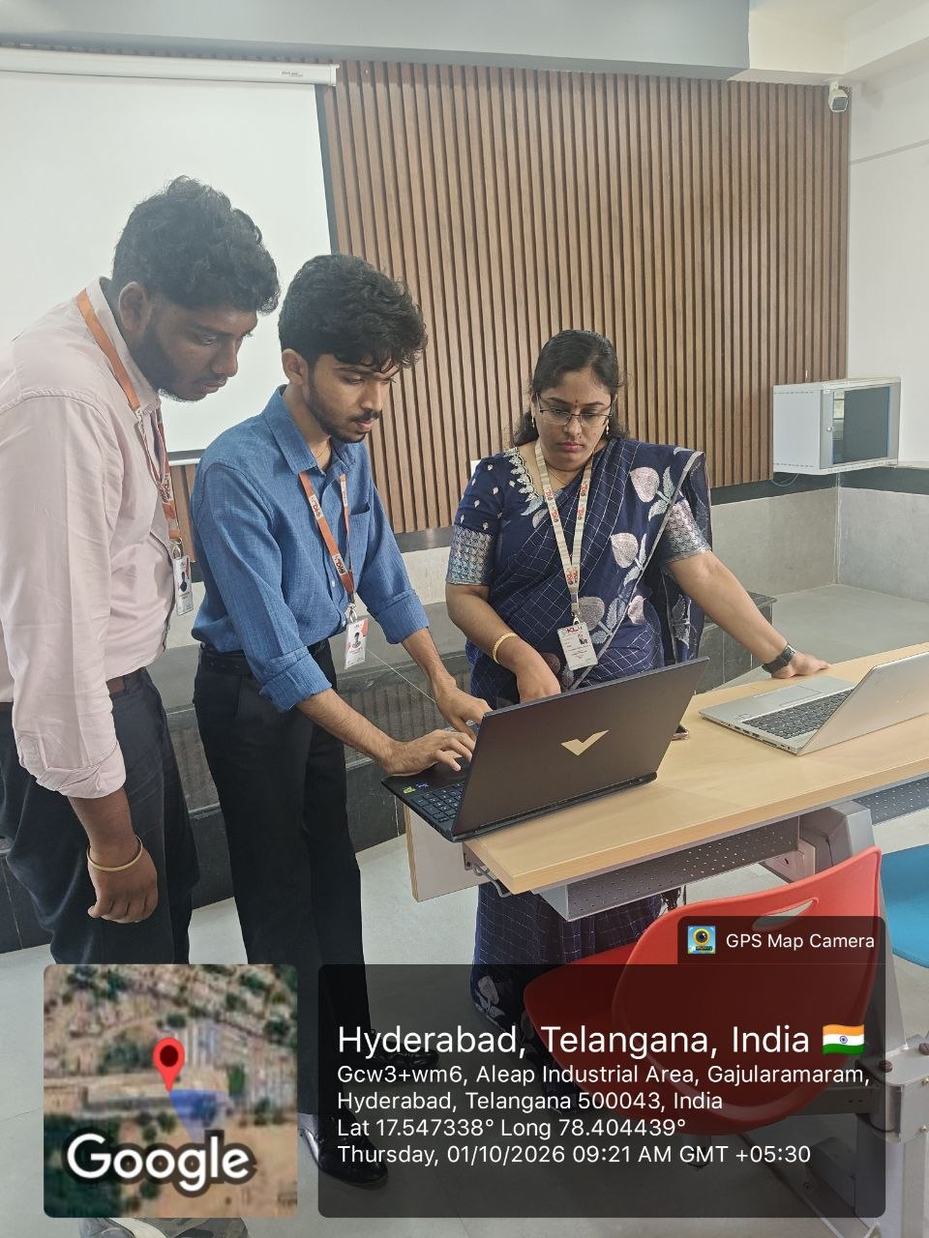

Review forms with guide signatures

